

LOCKOUT / TAGOUT PROCEDURES

Revision Number: 05

Reviewed and revised March 2021

Table of Contents

AUTOMOTIVE COLLISION REPAIR …………….………………………………………………………………………….. 6

Devillbliss Spray Booth ……………………………………………………………………………………………… 7

Binks Spray Booth …………………………………………………………………………………………………….. 8

Air Filter ……………………………………………………………………………………………………………………. 9

Chief Frame Machine ………………………………………………………………………………………………. 10

Dupont Paint Mixture System ………………………………………………………………………………….. 11

Automotive Collision Repair Exempt Equipment.......................................................... 12

AUTOMOTIVE TECHNOLOGY ………………………………………………………………………………………………. 13

Hunter GSP 9700 …………………………………………………………………………………………………….. 14

Benwil Lift #1 …………………………………………………………………………………………………………… 15

Benwil Lift #2 …………………………………………………………………………………………………………… 16

Rotary Lift 17 …………………………………………………………………………………………………………… 17

Wheeltronic Lift ………………………………………………………………………………………………………. 18

Hunter Front-End Lift ………………………………………………………………………………………………. 19

Globe Lift …………………………………………………………………………………………………………………. 20

Ammco Tire Changer ……………………………………………………………………………………………….. 21

Hunter Tire Changer ……………………………………………………………………………….……………….. 22

DSP 9000 Wheel Balancer ……………………………………………………………………………………….. 23

Automotive Technology Exempt Equipment ……………………………………………………………. 24

BUILDING CONSTRUCTION ………………………………………………………………………………………………….. 25

Jet Belt Sander…………………………………………………………………………………………………………. 26

Powermatic Planer ………………………………………………………………………………………………….. 27

Sawdust Collector ……………………………………………………………………………………………………. 28

14” Delta Radial Arm Saw ………………………………………………………………………………………… 29

Delta Unisaw #5 ………………………………………………………………………………………………………. 30

Newman 16” Joiner …………………………………………………………………………………………………. 31

Oliver Bench Saw …………………………………………………………………………………………………….. 32

Delta Unisaw 10” #4 ………………………………………………………………………………………………… 33

Delta Unisaw #6 ………………………………………………………………………………………………………. 34

Delta Wood Shaper #15 …………………………………………………………………………………………… 35

Delta Wood Shaper #11 …………………………………………………………………………………………... 36

Band Saw …………………………………………………………………………………………………………………. 37

Building Construction Exempt Equipment ………………………………………………………………. 38

DIESEL HYDRAULICS TECHNOLOGY ……………………………………………………………………………………… 39

Landa Parts Washer ...……………………………………………………………………………………………... 40

Mobile Units Repair ...................................................................................................... 41

Diesel Hydraulics Shop Exempt Equipment .................................................................. 42

ELECTRICAL CONSTRUCTION & MAINTENANCE ....................................................................... 43

Allen Bradley MCC ........................................................................................................ 44

Cutler Hammer Drive .................................................................................................... 45

Reliance Drive ............................................................................................................... 46

Electrical Construction & Maintenance Exempt Equipment ........................................ 47

INDUSTRIAL CONTROL & MEASURMENT TECHNOLOGY ........................................................... 48

25hp Variable Frequency Drive ..................................................................................... 49

VFD Motor ..................................................................................................................... 50

Process Control Trainer ................................................................................................. 51

Industrial Controls & Measurement Exempt Equipment .............................................. 52

PLUMBING & HEATING TECHNOLOGY ...................................................................................... 53

Submersible Pump ........................................................................................................ 54

Water Boiler .................................................................................................................. 55

Steam Boiler .................................................................................................................. 56

Warm Air Furnace ......................................................................................................... 57

Draft Booster ................................................................................................................. 58

Refrigeration Test Station #1 ......................................................................................... 59

Refrigeration Test Station #2 ......................................................................................... 60

Refrigeration Test Station #3 ......................................................................................... 61

Refrigeration Test Station #4 ......................................................................................... 62

Refrigeration Test Station #5 ......................................................................................... 63

Wind Generator.............................................................................................................. 64

Okofen Pellet Boiler ....................................................................................................... 65

Kedel Pellet Boiler .......................................................................................................... 66

Bunderus Pellet Boiler .................................................................................................... 67

Biasi Pellet Boiler ............................................................................................................ 68

Plumbing & Heating Exempt Equipment ........................................................................ 69

PRECISION MACHINING & COMPUTER NUMERICAL CONTROLS ............................................... 70

Clausing Vertical Mill #1 ................................................................................................. 71

Clausing Vertical Mill #2 ................................................................................................. 72

Clausing Vertical Mill #3 ................................................................................................. 73

Clausing Vertical Mill #4 ................................................................................................. 74

Acer E-Mill Vertical Mill #5 ............................................................................................. 75

Nardini Dynamic 1400 G Engine Lathe #1 ...................................................................... 76

Nardini Dynamic 1400 G Engine Lathe #2 ...................................................................... 77

Nardini Dynamic 1400 G Engine Lathe #3 ...................................................................... 78

Nardini Dynamic 1400 G Engine Lathe #4 ...................................................................... 79

Nardini Dynamic 1400 G Engine Lathe #5 ...................................................................... 80

Nardini Dynamic 1400 G Engine Lathe #6 ...................................................................... 81

Surface Grinder #1 ......................................................................................................... 82

Surface Grinder #2 ......................................................................................................... 83

Precision Metals Mill #1 ................................................................................................. 84

Precision Metals Mill #2.................................................................................................. 85

Precision Metals Lathe #1 .............................................................................................. 86

Precision Metals Lathe #2 .............................................................................................. 87

Precision Machining Exempt Equipment ....................................................................... 88

STRUCTURAL WELDING .............................................................................................................. 89

Clausing Drill Press .......................................................................................................... 90

Lincoln Air Filter .............................................................................................................. 91

Welder ............................................................................................................................ 92

Welding Exempt Equipment ........................................................................................... 93

WIND POWER TECHNOLOGY ...................................................................................................... 94

Vespas Wind Turbine ...................................................................................................... 95

MAINTENANCE & PHYSICAL PLANT PROCEDURES ..................................................................... 96

6” Grinder ....................................................................................................................... 97

Red Devil Paint Conditioner ............................................................................................ 98

12” Compound Miter Saw .............................................................................................. 99

Contractors Table Saw .................................................................................................. 100

Drill Press ...................................................................................................................... 101

Backhoe Loader ............................................................................................................ 102

Fronted Loader ............................................................................................................. 103

Sanding Truck ............................................................................................................... 104

Bull Dozer ..................................................................................................................... 105

Fork Lift ........................................................................................................................ 106

John Deere Tractor ...................................................................................................... 107

New Holland Tractor .................................................................................................... 108

Kioti CK27 Tractor ........................................................................................................ 109

Scissor Lift .................................................................................................................... 110

Snow Blower ................................................................................................................ 111

Passenger Vehicle ........................................................................................................ 112

Tractor Trailer .............................................................................................................. 113

Air Compressor ............................................................................................................ 114

Exhaust Fan ................................................................................................................. 115

Campus Boilers ............................................................................................................ 116

Campus Boilers ............................................................................................................ 117

Ceiling Mounted HV Units ........................................................................................... 118

HV Units ....................................................................................................................... 119

Roof Top HVAC Units ................................................................................................... 120

Fire Alarms ................................................................................................................... 121

Circulation Pumps ........................................................................................................ 122

Zone Valves .................................................................................................................. 123

Emergency Lighting ...................................................................................................... 124

Transformer Step up/down .......................................................................................... 125

Outside Lighting ............................................................................................................ 126

Overhead Door Opener ................................................................................................ 127

Electrical Receptacle ..................................................................................................... 128

Electrical Receptacle ..................................................................................................... 129

REED DINING COMMONS ........................................................................................................ 130

Convection Ovens ........................................................................................................ 131

Deep Fryers .................................................................................................................. 132

Steam Kettle ................................................................................................................. 133

Dishwasher ................................................................................................................... 134

Propane Pizza Oven ...................................................................................................... 135

Electronic Ballast Lighting Battery Backup ................................................................... 136

Electronic Ballast Lighting ............................................................................................ 137

Disposer ....................................................................................................................... 138

Mixer ............................................................................................................................ 130

Air Conditioner ............................................................................................................. 140

# AUTOMOTIVE COLLISION REPAIR

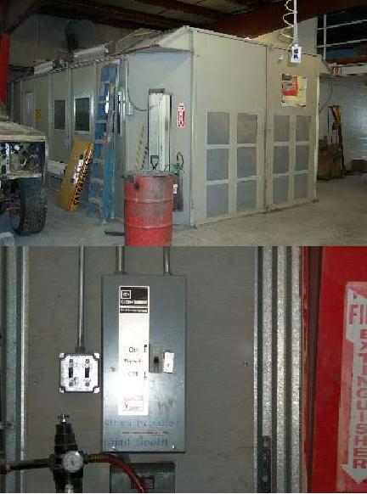

|  |  |  |
| --- | --- | --- |
| Devillbliss Spray Booth | | |
| *Step #* | *Energy Type* | **Shutdown Procedure** |
| 1 | any/all | Notify all affected employees of planned shutdown |
| 2 | any/all | Shut down equipment at operator’s controls |
| 3 | electrical | Move Paint Booth Breaker on wall to “off” position |
| 4 | electrical | Apply NMCC approved LOTO to Paint Booth Breaker |
| 5 | electrical | Activate start switch to verify removal of power |
| 6 | any/all | Perform required service according to manufacturer’s specs when available |

|  |  |  |
| --- | --- | --- |
| Devillbliss Spray Booth | | |
| *Step #* | *Energy Type* | **Startup Procedure** |
| 1 | any/all | Check for complete reassembly |
| 2 | any/all | Check equipment to insure complete removal of tools, repair materials, etc. |
| 3 | any/all | Replace all covers/guards |
| 4 | electrical | Remove LOTO from Paint Booth Breaker |
| 5 | electrical | Move Paint Booth Breaker to the “on” position |
| 6 | electrical | Activate start switch to verify proper operation |
| 7 | any/all | Notify affected employees that the servicing or maintenance is complete  and the machine or equipment is ready for use |

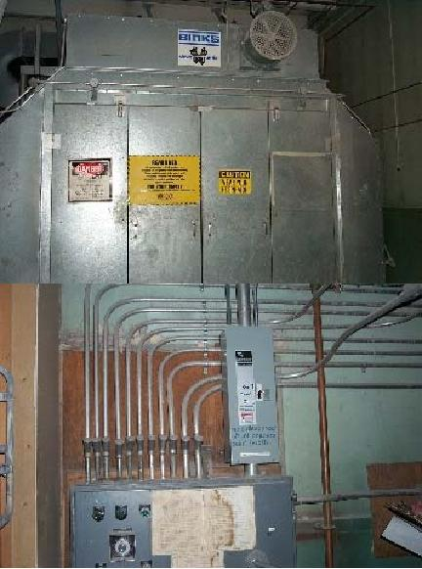

|  |  |  |
| --- | --- | --- |
| Binks Spray Booth | | |
| *Step #* | *Energy Type* | **Shutdown Procedure** |
| 1 | any/all | Notify all affected employees of planned shutdown |
| 2 | any/all | Shut down equipment at operator’s controls |
| 3 | electrical | Move Main Disconnect Paint Booth on wall to “off” position |
| 4 | electrical | Apply NMCC approved LOTO to Main Disconnect Paint Booth |
| 5 | electrical | Activate operator control by pulling spray booth exhaust fan knob and hold  for 30 seconds to verify removal of all power |
| 6 | any/all | Perform required service according to manufacturer’s specs when available |

|  |  |  |
| --- | --- | --- |
| Binks Spray Booth | | |
| *Step #* | *Energy Type* | **Startup Procedure** |
| 1 | any/all | Check for complete reassembly |
| 2 | any/all | Check equipment to insure complete removal of tools, repair materials, etc. |
| 3 | any/all | Replace all covers/guards |
| 4 | electrical | Remove LOTO from Main Disconnect Paint Booth |
| 5 | electrical | Move Main Disconnect Paint Booth to the “on” position |
| 6 | electrical/gas | Activate both systems to verify proper operation |
| 7 | any/all | Notify affected employees that the servicing or maintenance is complete  and the machine or equipment is ready for use |

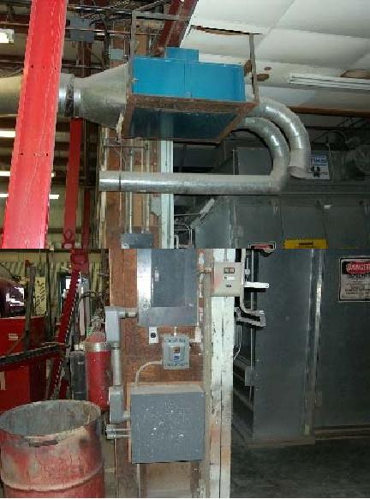

|  |  |  |
| --- | --- | --- |
| Air Filter | | |
| *Step #* | *Energy Type* | **Shutdown Procedure** |
| 1 | any/all | Notify all affected employees of planned shutdown |
| 2 | electrical | Move disconnect on wall to “off” position |
| 3 | electrical | Apply NMCC approved LOTO to disconnect |
| 4 | electrical | Measure voltage at air filter to verify proper removal of energy sources |
| 5 | any/all | Perform required service according to manufacturer’s specs when available |

|  |  |  |
| --- | --- | --- |
| Air Filter | | |
| *Step #* | *Energy Type* | **Startup Procedure** |
| 1 | any/all | Check for complete reassembly |
| 2 | any/all | Check equipment to insure complete removal of tools, repair materials, etc. |
| 3 | any/all | Replace all covers/guards |
| 4 | electrical | Remove LOTO from disconnect |
| 5 | electrical | Move disconnect to the “on” position |
| 6 | electrical | Activate system to verify proper operation |
| 7 | any/all | Notify affected employees that the servicing or maintenance is complete  and the machine or equipment is ready for use |

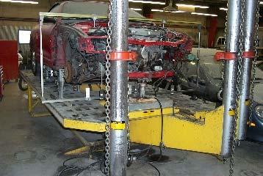

|  |  |  |
| --- | --- | --- |
| Chief Frame Machine | | |
| *Step #* | *Energy Type* | **Shutdown Procedure** |
| 1 | any/all | Notify all affected employees of planned shutdown |
| 2 | any/all | Shut down equipment at operator’s controls |
| 3 | electrical | Remove plug from receptacle |
| 4 | electrical | Place canister over plug |
| 5 | electrical | Apply NMCC approved LOTO to canister |
| 6 | hydraulic | Allow system to bleed down for 12 hours |
| 7 | hydraulic/  electrical | Activate operator control to verify removal of energy sources |
| 8 | any/all | Perform required service according to manufacturer’s specs when  available |

|  |  |  |
| --- | --- | --- |
| Chief Frame Machine | | |
| *Step #* | *Energy Type* | **Startup Procedure** |
| 1 | any/all | Check for complete reassembly |
| 2 | any/all | Check equipment to insure complete removal of tools, repair materials, etc. |
| 3 | any/all | Replace all covers/guards |
| 4 | air | Close bleeder valve on pump |
| 5 | electrical | Remove LOTO and canister from plug |
| 6 | electrical | Replace plug in receptacle |
| 7 | electrical/  hydraulic | Activate start button to verify proper operation |
| 8 | any/all | Notify affected employees that the servicing or maintenance is complete and  the machine or equipment is ready for use. |

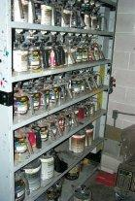

|  |  |  |
| --- | --- | --- |
| Dupont Paint Mixture System | | |
| *Step #* | *Energy Type* | **Shutdown Procedure** |
| 1 | any/all | Notify all affected employees of planned shutdown |
| 2 | any/all | Shut down equipment at operator’s controls |
| 3 | electrical | Move breaker #6 and panel A to the “off” position |
| 4 | electrical | Apply NMCC approved LOTO to breaker #6 |
| 5 | electrical | Activate operator controls to verify the removal of power |
| 6 | any/all | Perform required service according to manufacturer’s specs when available |

|  |  |  |
| --- | --- | --- |
| Dupont Paint Mixture System | | |
| *Step #* | *Energy Type* | **Startup Procedure** |
| 1 | any/all | Check for complete reassembly |
| 2 | any/all | Check equipment to insure complete removal of tools, repair materials, etc. |
| 3 | any/all | Replace all covers/guards |
| 4 | electrical | Remove LOTO from breaker #6 |
| 5 | electrical | Move breaker #6 in panel A to the “on” position |
| 6 | electrical | Activate system to verify proper operation |
| 7 | any/all | Notify affected employees that the servicing or maintenance is complete and  the machine or equipment is ready for use. |

|  |  |  |
| --- | --- | --- |
| ***Automotive Collision Shop Exempt Equipment*** This includes all mobile and/or connected, single energy source devices | | |
| *Step #* | *Energy Type* | **Shutdown Procedure** |
| 1 | any/all | Remove plug from receptacle. |
| 2 | any/all | If service person does not have complete control of plug or has to leave device for any length of time place protective canister over plug. |
| 3 | any/all | Apply NMCC approved LOTO |
| 4 | any/all | Reverse procedure to verify proper operation. |

# AUTOMOTIVE TECHNOLOGY

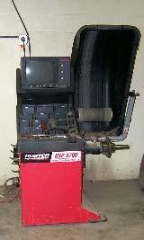

|  |  |  |
| --- | --- | --- |
| Hunter GSP 9700 | | |
| *Step #* | *Energy Type* | **Shutdown Procedure** |
| 1 | any/all | Notify all affected employees of planned shutdown |
| 2 | any/all | Turn off power at rear of equipment |
| 3 | gravity | Disconnect cord/plug |
| 4 | gravity/  hydraulic | Apply canister to cord/plug |
| 5 | electrical | Apply NMCC approved LOTO to canister |
| 6 | electrical | Disconnect air hose to bleed air pressure |
| 7 | any/all | Apply canister to air hose |
| 8 | electrical | Apply NMCC approved LOTO to canister |
| 9 | electrical | Turn on power switch at rear of equipment to verify energy sources have  been turned off |
| 10 | any/all | Perform required service according to manufacturer’s specs when available |

|  |  |  |
| --- | --- | --- |
| Hunter GSP 9700 | | |
| *Step #* | *Energy Type* | **Startup Procedure** |
| 1 | any/all | Check for complete reassembly |
| 2 | electrical | Turn on power switch at rear of equipment to verify energy sources have  been turned off |
| 3 | electrical | Remove NMCC approved LOTO from canister |
| 4 | any/all | Remove canister from air hose |
| 5 | electrical | Reconnect air hose |
| 6 | electrical | Remove NMCC approved LOTO from canister |
| 7 | gravity/  hydraulic | Remove canister from cord/plug |
| 8 | gravity | Connect cord/plug |
| 9 | any/all | Turn on power at rear of equipment |
| 10 | any/all | Activate to verify proper operation |
| 11 | any/all | Notify affected employees that the servicing or maintenance is complete and  the machine or equipment is ready for use. |

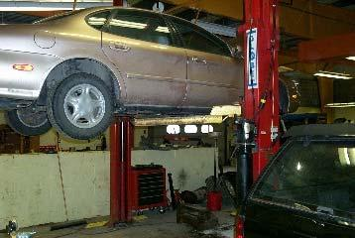

|  |  |  |
| --- | --- | --- |
| Benwil Lift #1 | | |
| *Step #* | *Energy Type* | **Shutdown Procedure** |
| 1 | any/all | Notify all affected employees of planned shutdown |
| 2 | gravity | Place lift into zero gravity condition (on floor or on locks) |
| 3 | gravity/  hydraulic | Activate hydraulic release valve to remove pressure/insure lift is immobile |
| 4 | electrical | Move disconnect to “off” position |
| 5 | electrical | Apply NMCC approved LOTO to disconnect |
| 6 | electrical | Activate raise button to verify removal of power |
| 7 | any/all | Perform required service according to manufacturer’s specs when available |

|  |  |  |
| --- | --- | --- |
| Benwil Lift #1 | | |
| *Step #* | *Energy Type* | **Startup Procedure** |
| 1 | any/all | Check for complete reassembly |
| 2 | any/all | Activate raise button to verify removal of power |
| 3 | any/all | Remove NMCC LOTO from disconnect |
| 4 | electrical | Move disconnect to “on” position |
| 5 | both | Test operate lift to verify proper operation |
| 6 | any/all | Notify affected employees that the servicing or maintenance is complete and  the machine or equipment is ready for use |

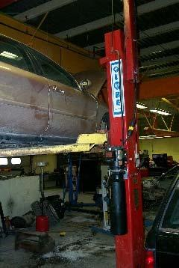

|  |  |  |
| --- | --- | --- |
| Benwil Lift #2 | | |
| *Step #* | *Energy Type* | **Shutdown Procedure** |
| 1 | any/all | Notify all affected employees of planned shutdown |
| 2 | any/all | Shut down equipment at operator’s controls |
| 3 | gravity | Place lift into zero gravity condition (on floor or on locks) |
| 4 | gravity/  hydraulic | Activate hydraulic release valve to remove pressure/insure lift is immobile |
| 5 | electrical | Move disconnect to “off” position |
| 6 | electrical | Apply NMCC approved LOTO to disconnect |
| 7 | electrical | Activate raise button to verify removal of power |
| 8 | any/all | Perform required service according to manufacturer’s specs when available |

|  |  |  |
| --- | --- | --- |
| Benwil Lift #2 | | |
| *Step #* | *Energy Type* | **Startup Procedure** |
| 1 | any/all | Check for complete reassembly |
| 2 | electric | Activate raise button to verify removal of power |
| 3 | any/all | Check equipment to insure complete removal of tools, repair materials, etc. |
| 4 | any/all | Replace all covers/guards |
| 5 | electrical | Remove LOTO from disconnect |
| 6 | electrical | Move disconnect to the “on” position |
| 7 | both | Test operate lift to verify proper operation |
| 8 | any/all | Notify affected employees that the servicing or maintenance is complete and  the machine or equipment is ready for use |

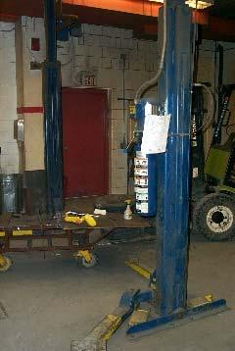

|  |  |  |
| --- | --- | --- |
| Rotary Lift | | |
| *Step #* | *Energy Type* | **Shutdown Procedure** |
| 1 | any/all | Notify all affected employees of planned shutdown |
| 2 | any/all | Shut down equipment at operator’s controls |
| 3 | gravity | Place lift into zero gravity condition (on floor or on locks) |
| 4 | gravity/  hydraulic | Activate hydraulic release valve to remove pressure/insure lift is immobile |
| 5 | electrical | Move disconnect to “off” position |
| 6 | electrical | Apply NMCC approved LOTO to disconnect |
| 7 | electrical | Activate raise button to verify removal of power |
| 8 | any/all | Perform required service according to manufacturer’s specs when available |

|  |  |  |
| --- | --- | --- |
| Rotary Lift | | |
| *Step #* | *Energy Type* | **Startup Procedure** |
| 1 | any/all | Check for complete reassembly |
| 2 | electric | Activate raise button to verify removal of power |
| 3 | any/all | Check equipment to insure complete removal of tools, repair materials, etc. |
| 4 | any/all | Replace all covers/guards |
| 5 | electrical | Remove LOTO from disconnect |
| 6 | electrical | Move disconnect to the “on” position |
| 7 | both | Test operate lift to verify proper operation |
| 8 | any/all | Notify affected employees that the servicing or maintenance is complete and  the machine or equipment is ready for use |

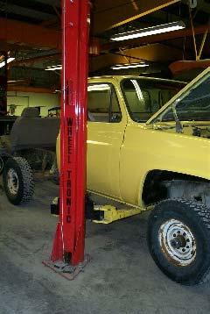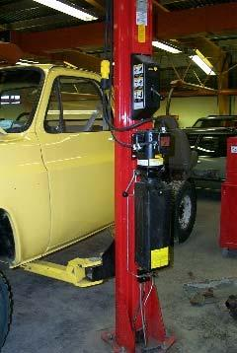

|  |  |  |
| --- | --- | --- |
| Wheeltronic Lift | | |
| *Step #* | *Energy Type* | **Shutdown Procedure** |
| 1 | any/all | Notify all affected employees of planned shutdown |
| 2 | any/all | Shut down equipment at operator’s controls |
| 3 | gravity | Place lift into zero gravity condition (on floor or on locks) |
| 4 | gravity/  hydraulic | Activate hydraulic release valve to remove pressure/insure lift is immobile |
| 5 | electrical | Move disconnect to “off” position |
| 6 | electrical | Apply NMCC approved LOTO to disconnect |
| 7 | electrical | Activate raise button to verify removal of power |
| 8 | any/all | Perform required service according to manufacturer’s specs when available |

|  |  |  |
| --- | --- | --- |
| Wheeltronic Lift | | |
| *Step #* | *Energy Type* | **Startup Procedure** |
| 1 | any/all | Check for complete reassembly |
| 2 | electric | Activate raise button to verify removal of power |
| 3 | any/all | Check equipment to insure complete removal of tools, repair materials, etc. |
| 4 | any/all | Replace all covers/guards |
| 5 | electrical | Remove LOTO from disconnect |
| 6 | electrical | Move disconnect to the “on” position |
| 7 | both | Test operate lift to verify proper operation |
| 8 | any/all | Notify affected employees that the servicing or maintenance is complete and  the machine or equipment is ready for use |

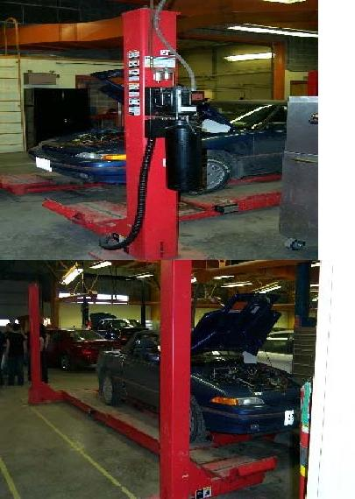

|  |  |  |
| --- | --- | --- |
| Hunter Front-End Lift | | |
| *Step #* | *Energy Type* | **Shutdown Procedure** |
| 1 | any/all | Notify all affected employees of planned shutdown |
| 2 | any/all | Shut off air valve and disconnect hose to bleed air pressure |
| 3 | hydraulic | Apply NMCC Approved LOTO to air valve |
| 4 | gravity | Place lift into zero gravity condition (on floor or on locks) |
| 5 | gravity/  hydraulic | Activate hydraulic release valve to remove pressure/insure lift is immobile |
| 6 | electrical | Move disconnect to “off” position |
| 7 | electrical | Apply NMCC approved LOTO to disconnect |
| 8 | any/all | Perform required service according to manufacturer’s specs when available |

|  |  |  |
| --- | --- | --- |
| Hunter Front-End Lift | | |
| *Step #* | *Energy Type* | **Startup Procedure** |
| 1 | any/all | Check for complete reassembly |
| 2 | any/all | Check equipment to insure complete removal of tools, repair materials, etc. |
| 3 | any/all | Replace all covers/guards |
| 4 | electrical | Remove LOTO from disconnect |
| 5 | electrical | Move disconnect to the “on” position |
| 6 | hydraulic | Remove LOTO from air valve |
| 7 | both | Test operate lift to verify proper operation |
| 8 | any/all | Notify affected employees that the servicing or maintenance is complete and  the machine or equipment is ready for use |

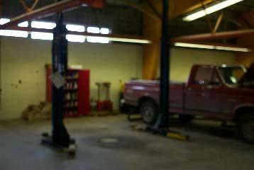

|  |  |  |
| --- | --- | --- |
| Globe Lift | | |
| *Step #* | *Energy Type* | **Shutdown Procedure** |
| 1 | any/all | Notify all affected employees of planned shutdown |
| 2 | any/all | Shut down equipment at operator’s controls |
| 3 | gravity | Place lift into zero gravity condition (on floor or on locks) |
| 4 | gravity/  hydraulic | Activate hydraulic release valve to remove pressure/insure lift is immobile |
| 5 | electrical | Move disconnect to “off” position |
| 6 | electrical | Apply NMCC approved LOTO to disconnect |
| 7 | electrical | Activate Raise Button to verify the removal of power |
| 8 | any/all | Perform required service according to manufacturer’s specs when available |

|  |  |  |
| --- | --- | --- |
| Globe Lift | | |
| *Step #* | *Energy Type* | **Startup Procedure** |
| 1 | any/all | Check for complete reassembly |
| 2 | any/all | Check equipment to insure complete removal of tools, repair materials, etc. |
| 3 | any/all | Replace all covers/guards |
| 4 | electrical | Remove LOTO from disconnect |
| 5 | electrical | Move disconnect to the “on” position |
| 6 | any/all | Startup equipment operator’s controls |
| 7 | both | Test operate lift to verify proper operation |
| 8 | any/all | Notify affected employees that the servicing or maintenance is complete and  the machine or equipment is ready for use |

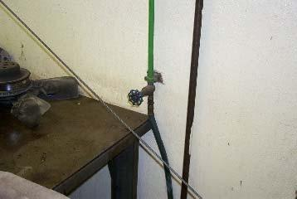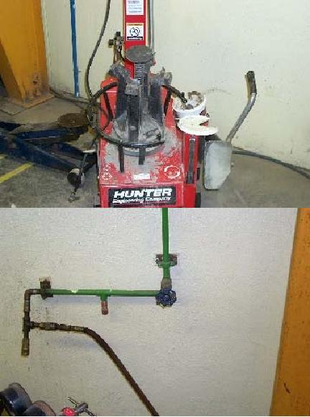

|  |  |  |
| --- | --- | --- |
| Ammco Tire Changer | | |
| *Step #* | *Energy Type* | **Shutdown Procedure** |
| 1 | any/all | Notify all affected employees of planned shutdown |
| 2 | air | Close main airline valve |
| 3 | air | Remove air hose to bleed air pressure |
| 4 | air | Place NMCC approved LOTO on valve |
| 5 | air | Activate device to verify removal of energy source |
| 6 | any/all | Perform required service according to manufacturer’s specs when available |

|  |  |  |
| --- | --- | --- |
| Ammco Tire Changer | | |
| *Step #* | *Energy Type* | **Startup Procedure** |
| 1 | any/all | Check for complete reassembly |
| 2 | any/all | Check equipment to insure complete removal of tools, repair materials, etc. |
| 3 | any/all | Replace all covers/guards |
| 4 | air | Remove LOTO from control valve |
| 5 | air | Reconnect air hose |
| 6 | air | Open control valve |
| 7 | air | Activate changer to verify proper operation |
| 8 | any/all | Notify affected employees that the servicing or maintenance is complete and  the machine or equipment is ready for use |



|  |  |  |
| --- | --- | --- |
| Hunter Tire Changers | | |
| *Step #* | *Energy Type* | **Shutdown Procedure** |
| 1 | any/all | Notify all affected employees of planned shutdown |
| 2 | air | Close main airline valve |
| 3 | air | Remove air hose to bleed air pressure |
| 4 | air | Place NMCC approved LOTO on valve |
| 5 | air | Activate device to verify removal of energy source |
| 6 | any/all | Perform required service according to manufacturer’s specs when available |

|  |  |  |
| --- | --- | --- |
| Hunter Tire Changers | | |
| *Step #* | *Energy Type* | **Startup Procedure** |
| 1 | any/all | Check for complete reassembly |
| 2 | any/all | Check equipment to insure complete removal of tools, repair materials, etc. |
| 3 | any/all | Replace all covers/guards |
| 4 | air | Remove LOTO from control valve |
| 5 | air | Reconnect air hose |
| 6 | air | Open control valve |
| 7 | air | Activate changer to verify proper operation |
| 8 | any/all | Notify affected employees that the servicing or maintenance is complete and  the machine or equipment is ready for use |

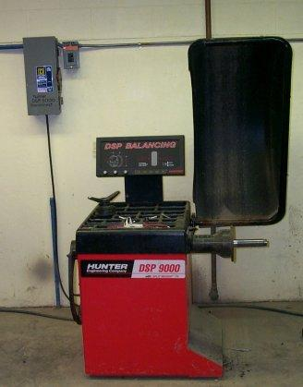

|  |  |  |
| --- | --- | --- |
| DSP 9000 Wheel Balancer | | |
| *Step #* | *Energy Type* | **Shutdown Procedure** |
| 1 | any/all | Notify all affected employees of planned shutdown |
| 2 | any/all | Shutdown equipment at power switch located at the rear of equipment |
| 3 | electrical | Move disconnect on wall to “off” position |
| 4 | electrical | Apply NMCC approved LOTO to disconnect |
| 5 | electrical | Activate balancer to verify removal of power |
| 6 | any/all | Perform required service according to manufacturer’s specs when available |

|  |  |  |
| --- | --- | --- |
| DSP 9000 Wheel Balancer | | |
| *Step #* | *Energy Type* | **Startup Procedure** |
| 1 | any/all | Check for complete reassembly |
| 2 | any/all | Check equipment to insure complete removal of tools, repair materials, etc. |
| 3 | any/all | Replace all covers/guards |
| 4 | electrical | Remove LOTO from disconnect |
| 5 | electrical | Move disconnect to “on” position |
| 6 | any/all | Turn on equipment at power switch located at the rear of equipment |
| 7 | electrical | Activate changer to verify proper operation |
| 8 | any/all | Notify affected employees that the servicing or maintenance is complete  and the machine or equipment is ready for use |

|  |  |  |
| --- | --- | --- |
| ***Automotive Technology Exempt Equipment*** This includes all mobile and/or connected, single energy source devices | | |
| *Step #* | *Energy Type* | **Shutdown Procedure** |
| 1 | any/all | Remove plug from receptacle. |
| 2 | any/all | If service person does not have complete control of plug or has to leave device |
| 3 | any/all | Apply NMCC approved LOTO |
| 4 | any/all | Reverse procedure to verify proper operation. |

# 

# BUILDING CONSTRUCTION

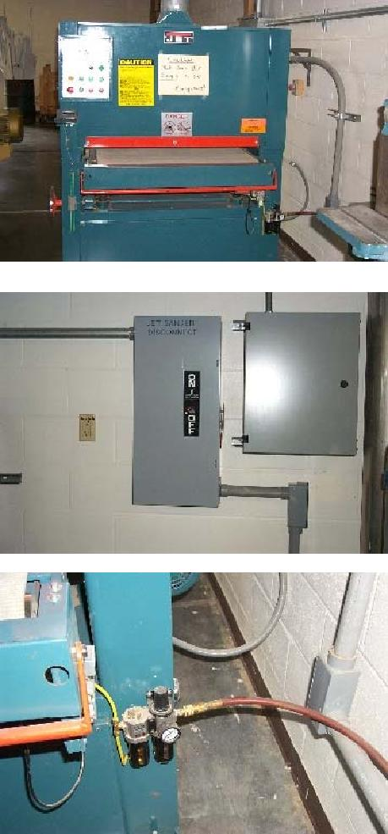

|  |  |  |
| --- | --- | --- |
| Jet Belt Sander | | |
| *Step #* | *Energy Type* | **Shutdown Procedure** |
| 1 | any/all | Notify all affected employees of planned shutdown |
| 2 | any/all | Shutdown equipment by pressing the two off buttons and then turn off main |
|  |  | switch. |
| 3 | electrical | Place Jet Sander disconnect in the off position |
| 4 | electrical | Apply NMCC approved LOTO to disconnect |
| 5 | air | Remove air supply line at quick disconnect on sander |
| 6 | electric/air | Apply canister to air hose |
| 7 | electric/air | Apply NMCC approved LOTO to canister |
| 8 | electric | Press equipment start button to verify all energy sources are removed |
| 9 | any/all | Perform required service according to manufacturer’s specs when available |

|  |  |  |
| --- | --- | --- |
| Jet Belt Sander | | |
| *Step #* | *Energy Type* | **Startup Procedure** |
| 1 | any/all | Check for complete reassembly |
| 2 | any/all | Check equipment to insure complete removal of tools, repair materials, etc. |
| 3 | any/all | Replace all service covers and tool guards |
| 4 | air | Remove LOTO from canister |
| 5 | air | Reconnect air hose to sander |
| 6 | electrical | Remove LOTO from sander disconnect |
| 7 | electrical | Move disconnect to “on” position |
| 8 | electrical/air | Activate equipment – verify safe operation |
| 9 | any/all | Notify affected employees that the servicing or maintenance is complete  and the machine or equipment is ready for use. |

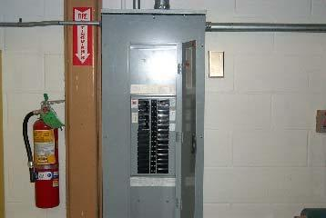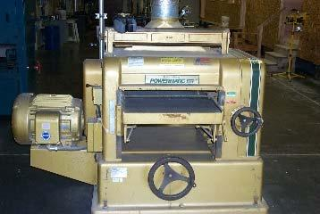

|  |  |  |
| --- | --- | --- |
| Powermatic Planer | | |
| *Step #* | *Energy Type* | **Shutdown Procedure** |
| 1 | any/all | Notify all affected employees of planned shutdown |
| 2 | any/all | Shutdown equipment by pressing stop button and placing feed switch in off |
|  |  | position. |
| 3 | electrical | Move breaker #7,9,11 in panel P to “off” position |
| 4 | electrical | Apply NMCC approved LOTO to breaker #7,9,11 |
| 5 | any/all | Press start button and feed in on position to verify all energy sources are |
|  |  | removed. |
| 6 | any/all | Perform required service according to manufacturer’s specs when available |

|  |  |  |
| --- | --- | --- |
| Powermatic Planer | | |
| *Step #* | *Energy Type* | **Startup Procedure** |
| 1 | any/all | Check for complete reassembly |
| 2 | any/all | Check equipment to insure complete removal of tools, repair materials, etc. |
| 3 | any/all | Replace all covers/guards |
| 4 | air | Remove LOTO from breaker #7,9,11 in panel P |
| 5 | electrical | Move breaker to the “on” position |
| 6 | electrical | Activate equipment – verify safe operation |
| 7 | any/all | Notify affected employees that the servicing or maintenance is complete  and the machine or equipment is ready for use. |

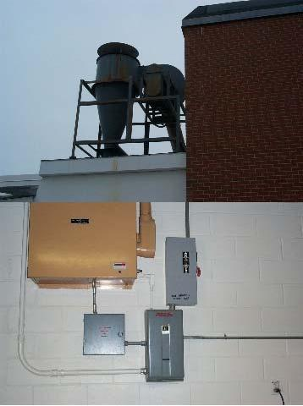

|  |  |  |
| --- | --- | --- |
| Sawdust Collector | | |
| *Step #* | *Energy Type* | **Shutdown Procedure** |
| 1 | any/all | Notify all affected employees of planned shutdown |
| 2 | any/all | Shutdown equipment at Blower Control |
| 3 | electrical | Move Cyclone disconnect to the off position |
| 4 | electrical | Apply NMCC approved LOTO to disconnect |
| 5 | any/all | Move blower control switch to manual to verify power is off |
| 6 | any/all | Perform required service according to manufacturer’s specs when available |

|  |  |  |
| --- | --- | --- |
| Sawdust Collector | | |
| *Step #* | *Energy Type* | **Startup Procedure** |
| 1 | any/all | Check for complete reassembly |
| 2 | any/all | Check equipment to insure complete removal of tools, repair materials, etc. |
| 3 | any/all | Replace all covers/guards |
| 4 | air | Remove LOTO from cyclone disconnect |
| 5 | electrical | Move disconnect to the on position |
| 6 | electrical | Move blower control switch to manual to check for proper operation |
| 7 | any/all | Notify affected employees that the servicing or maintenance is complete  and the machine or equipment is ready for use. Blower control circuit needs to be turned off in Automotive Technology Shop. |

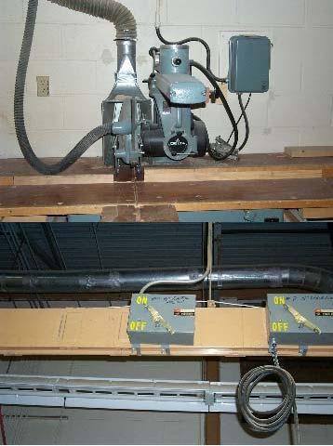

|  |  |  |
| --- | --- | --- |
| 14” Delta Radial Arm Saw | | |
| *Step #* | *Energy Type* | **Shutdown Procedure** |
| 1 | any/all | Notify all affected employees of planned shutdown |
| 2 | any/all | Shut down equipment at operator’s controls |
| 3 | electrical | Place ladder beneath bus bar breaker #9 |
| 4 | electrical | Move disconnect #9 to the off position |
| 5 | electrical | Apply NMCC approved LOTO to breaker #9 |
| 6 | electrical | Activate start button to verify power is off |
| 7 | any/all | Perform required service according to manufacturer’s specs when available |

|  |  |  |
| --- | --- | --- |
| 14” Delta Radial Arm Saw | | |
| *Step #* | *Energy Type* | **Startup Procedure** |
| 1 | any/all | Check for complete reassembly |
| 2 | any/all | Check equipment to insure complete removal of tools, repair materials, etc. |
| 3 | electrical | Replace all covers/guards |
| 4 | electrical | Remove LOTO from breaker #9 |
| 5 | electrical | Move breaker #9 to the “on” position |
| 6 | electrical | Activate start button to verify proper operation |
| 7 | any/all | Notify affected employees that the servicing or maintenance is complete  and the machine or equipment is ready for use. |

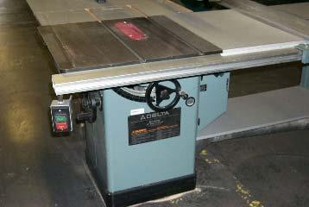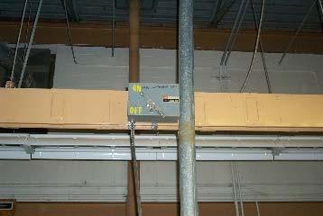

|  |  |  |
| --- | --- | --- |
| Delta Unisaw #5 | | |
| *Step #* | *Energy Type* | **Shutdown Procedure** |
| 1 | any/all | Notify all affected employees of planned shutdown |
| 2 | any/all | Shut down equipment at operator’s controls |
| 3 | electrical | Place ladder beneath breaker #5 on bus bar |
| 4 | electrical | Move disconnect #5 to the off position |
| 5 | electrical | Apply NMCC approved LOTO to breaker #5 |
| 6 | electrical | Activate start button to verify power is off |
| 7 | any/all | Perform required service according to manufacturer’s specs when available |

|  |  |  |
| --- | --- | --- |
| Delta Unisaw #5 | | |
| *Step #* | *Energy Type* | **Startup Procedure** |
| 1 | any/all | Check for complete reassembly |
| 2 | any/all | Check equipment to insure complete removal of tools, repair materials, etc. |
| 3 | electrical | Replace all covers/guards |
| 4 | electrical | Remove LOTO from breaker #5 |
| 5 | electrical | Move breaker #5 to the “on” position |
| 6 | electrical | Activate start button to verify proper operation |
| 7 | any/all | Notify affected employees that the servicing or maintenance is complete  and the machine or equipment is ready for use. |

## 

|  |  |  |
| --- | --- | --- |
| Newman 16” Joiner | | |
| *Step #* | *Energy Type* | **Shutdown Procedure** |
| 1 | any/all | Notify all affected employees of planned shutdown |
| 2 | any/all | Shut down equipment at operator’s controls |
| 3 | electrical | Place ladder under breaker #12 |
| 4 | electrical | Move breaker #12 to the “off” position |
| 5 | electrical | Apply NMCC approved LOTO to breaker #12 |
| 6 | electrical | Activate start button to verify power is off |
| 7 | any/all | Perform required service according to manufacturer’s specs when available |

|  |  |  |
| --- | --- | --- |
| Newman 16” Joiner | | |
| *Step #* | *Energy Type* | **Startup Procedure** |
| 1 | any/all | Check for complete reassembly |
| 2 | any/all | Check equipment to insure complete removal of tools, repair materials, etc. |
| 3 | electrical | Replace all covers/guards |
| 4 | electrical | Remove LOTO from breaker #12 |
| 5 | electrical | Move breaker #12 to the “on” position |
| 6 | electrical | Activate start button to verify proper operation |
| 7 | any/all | Notify affected employees that the servicing or maintenance is complete  and the machine or equipment is ready for use. |

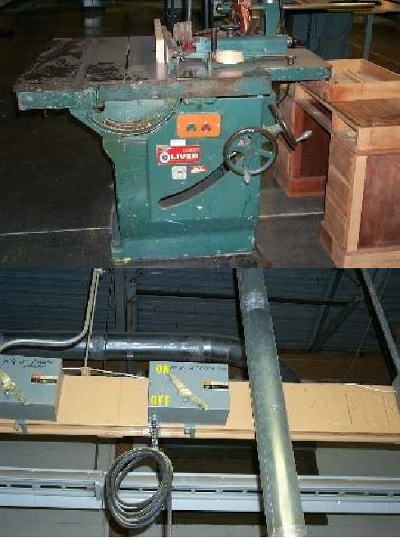

|  |  |  |
| --- | --- | --- |
| Oliver Bench Saw | | |
| *Step #* | *Energy Type* | **Shutdown Procedure** |
| 1 | any/all | Notify all affected employees of planned shutdown |
| 2 | any/all | Shut down equipment at operator’s controls |
| 3 | any/all | Place ladder under breaker #8 |
| 4 | electrical | Move breaker #8 to the “off” position |
| 5 | electrical | Apply NMCC approved LOTO to breaker #8 |
| 6 | electrical | Activate start button to verify power is off |
| 7 | any/all | Perform required service according to manufacturer’s specs when available |

|  |  |  |
| --- | --- | --- |
| Oliver Bench Saw | | |
| *Step #* | *Energy Type* | **Startup Procedure** |
| 1 | any/all | Check for complete reassembly |
| 2 | any/all | Check equipment to insure complete removal of tools, repair materials, etc. |
| 3 | any/all | Replace all covers/guards |
| 4 | electrical | Remove LOTO from breaker #8 |
| 5 | electrical | Move breaker #8 to the “on” position |
| 6 | electrical | Activate start button to verify proper operation |
| 7 | any/all | Notify affected employees that the servicing or maintenance is complete  and the machine or equipment is ready for use. |

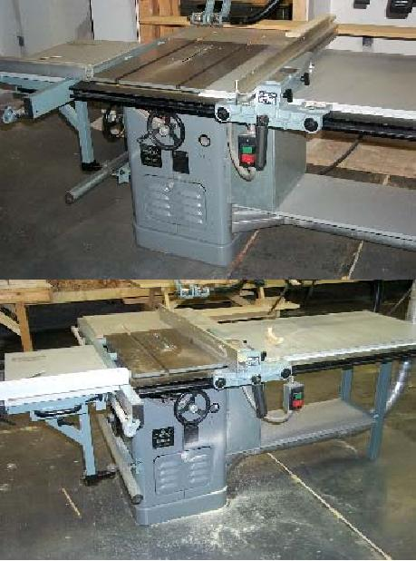

|  |  |  |
| --- | --- | --- |
| Delta Unisaw 10” #4 | | |
| *Step #* | *Energy Type* | **Shutdown Procedure** |
| 1 | any/all | Notify all affected employees of planned shutdown |
| 2 | any/all | Shut down equipment at operator’s controls |
| 3 | any/all | Place ladder under breaker #4 |
| 4 | electrical | Move breaker #4 to the “off” position |
| 5 | electrical | Apply NMCC approved LOTO to breaker #4 |
| 6 | electrical | Activate start button to verify power is off |
| 7 | any/all | Perform required service according to manufacturer’s specs when available |

|  |  |  |
| --- | --- | --- |
| Delta Unisaw 10” #4 | | |
| *Step #* | *Energy Type* | **Startup Procedure** |
| 1 | any/all | Check for complete reassembly |
| 2 | any/all | Check equipment to insure complete removal of tools, repair materials, etc. |
| 3 | any/all | Replace all covers/guards |
| 4 | electrical | Remove LOTO from breaker #4 |
| 5 | electrical | Move breaker #4 to the “on” position |
| 6 | electrical | Activate start button to verify proper operation |
| 7 | any/all | Notify affected employees that the servicing or maintenance is complete  and the machine or equipment is ready for use. |

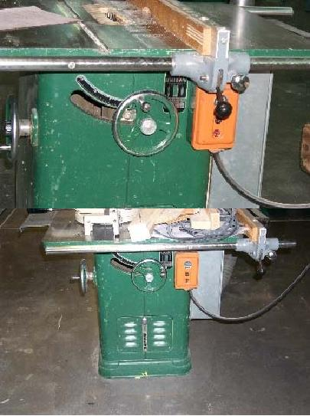

|  |  |  |
| --- | --- | --- |
| Delta Unisaw #6 | | |
| *Step #* | *Energy Type* | **Shutdown Procedure** |
| 1 | any/all | Notify all affected employees of planned shutdown |
| 2 | any/all | Shut down equipment at operator’s controls |
| 3 | any/all | Place ladder under breaker #6 |
| 4 | electrical | Move breaker #6 to the “off” position |
| 5 | electrical | Apply NMCC approved LOTO to breaker #6 |
| 6 | electrical | Activate start button to verify power is off |
| 7 | any/all | Perform required service according to manufacturer’s specs when available |

|  |  |  |
| --- | --- | --- |
| Delta Unisaw #6 | | |
| *Step #* | *Energy Type* | **Startup Procedure** |
| 1 | any/all | Check for complete reassembly |
| 2 | any/all | Check equipment to insure complete removal of tools, repair materials, etc. |
| 3 | any/all | Replace all covers/guards |
| 4 | electrical | Remove LOTO from breaker #6 |
| 5 | electrical | Move breaker #6 to the “on” position |
| 6 | electrical | Activate start button to verify proper operation |
| 7 | any/all | Notify affected employees that the servicing or maintenance is complete  and the machine or equipment is ready for use. |

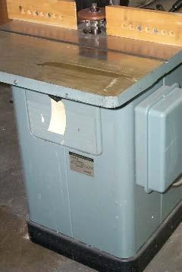

|  |  |  |
| --- | --- | --- |
| Delta Wood Shaper #15 | | |
| *Step #* | *Energy Type* | **Shutdown Procedure** |
| 1 | any/all | Notify all affected employees of planned shutdown |
| 2 | any/all | Shut down equipment at operator’s controls |
| 3 | any/all | Place ladder under breaker #15 |
| 4 | electrical | Move breaker #15 to the “off” position |
| 5 | electrical | Apply NMCC approved LOTO to breaker #15 |
| 6 | electrical | Activate start button to verify power is off |
| 7 | any/all | Perform required service according to manufacturer’s specs when available |

|  |  |  |
| --- | --- | --- |
| Delta Wood Shaper #15 | | |
| *Step #* | *Energy Type* | **Startup Procedure** |
| 1 | any/all | Check for complete reassembly |
| 2 | any/all | Check equipment to insure complete removal of tools, repair materials, etc. |
| 3 | any/all | Replace all covers/guards |
| 4 | electrical | Remove LOTO from breaker #15 |
| 5 | electrical | Move breaker #15 to the “on” position |
| 6 | electrical | Activate start button to verify proper operation |
| 7 | any/all | Notify affected employees that the servicing or maintenance is complete  and the machine or equipment is ready for use. |

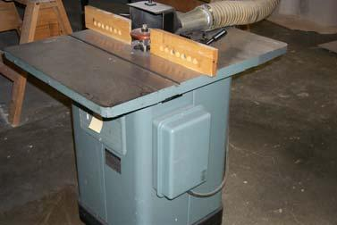

|  |  |  |
| --- | --- | --- |
| Delta Wood Shaper #11 | | |
| *Step #* | *Energy Type* | **Shutdown Procedure** |
| 1 | any/all | Notify all affected employees of planned shutdown |
| 2 | any/all | Shut down equipment at operator’s controls |
| 3 | any/all | Place ladder under breaker #11 |
| 4 | electrical | Move breaker #11 to the “off” position |
| 5 | electrical | Apply NMCC approved LOTO to breaker #11 |
| 6 | electrical | Activate start button to verify power is off |
| 7 | any/all | Perform required service according to manufacturer’s specs when available |

|  |  |  |
| --- | --- | --- |
| Delta Wood Shaper #11 | | |
| *Step #* | *Energy Type* | **Startup Procedure** |
| 1 | any/all | Check for complete reassembly |
| 2 | any/all | Check equipment to insure complete removal of tools, repair materials, etc. |
| 3 | any/all | Replace all covers/guards |
| 4 | electrical | Remove LOTO from breaker #11 |
| 5 | electrical | Move breaker #11 to the “on” position |
| 6 | electrical | Activate start button to verify proper operation |
| 7 | any/all | Notify affected employees that the servicing or maintenance is complete  and the machine or equipment is ready for use. |

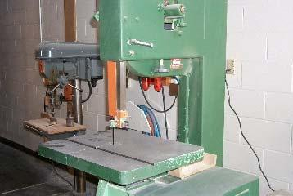

|  |  |  |
| --- | --- | --- |
| Band Saw | | |
| *Step #* | *Energy Type* | **Shutdown Procedure** |
| 1 | any/all | Notify all affected employees of planned shutdown |
| 2 | any/all | Shut down equipment at operator’s controls |
| 3 | electrical | Place ladder under breaker #16 |
| 4 | electrical | Move breaker #16 to the “off” position |
| 5 | electrical | Apply NMCC approved LOTO to breaker #16 |
| 6 | any/all | Activate start button to verify power is off |
| 7 | any/all | Perform required service according to manufacturer’s specs when available |

|  |  |  |
| --- | --- | --- |
| Band Saw | | |
| *Step #* | *Energy Type* | **Startup Procedure** |
| 1 | any/all | Check for complete reassembly |
| 2 | any/all | Check equipment to insure complete removal of tools, repair materials, etc. |
| 3 | electrical | Replace all covers/guards |
| 4 | electrical | Remove LOTO from breaker #16 |
| 5 | electrical | Move breaker #16 to the “on” position |
| 6 | any/all | Activate start button to verify proper operation |
| 7 | any/all | Notify affected employees that the servicing or maintenance is complete  and the machine or equipment is ready for use. |

|  |  |  |
| --- | --- | --- |
| ***Building Construction Exempt Equipment*** This includes all mobile and/or connected, single energy source devices | | |
| *Step #* | *Energy Type* | **Shutdown Procedure** |
| 1 | any/all | Remove plug from receptacle. |
| 2 | any/all | If service person does not have complete control of plug or has to leave device |
| 3 | electrical | Replace all covers/guards |
| 4 | electrical | Remove LOTO from breaker #16 |

# DIESEL HYDRAULICS TECHNOLOGY

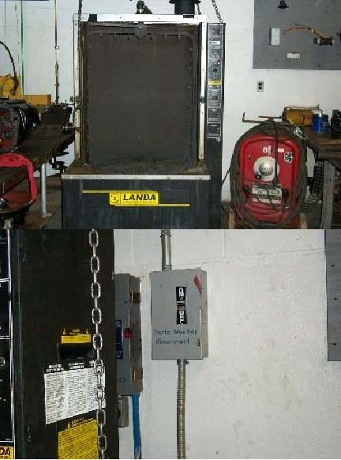

|  |  |  |
| --- | --- | --- |
| Landa Parts Washer | | |
| *Step #* | *Energy Type* | **Shutdown Procedure** |
| 1 | any/all | Notify all affected employees of planned shutdown |
| 2 | any/all | Shutdown equipment at 3 operator controls (Heater, Wash Cycle, and Oil  Skimmer) |
| 3 | electrical | Move disconnect on wall to the “off” position |
| 4 | electrical | Apply NMCC approved LOTO to disconnect |
| 5 | electrical | Activate start button to verify removal of power |
| 6 | thermal | Allow equipment to cool |
| 7 | any/all | Perform required service according to manufacturer’s specs when available |

|  |  |  |
| --- | --- | --- |
| Landa Parts Washer | | |
| *Step #* | *Energy Type* | **Startup Procedure** |
| 1 | any/all | Check for complete reassembly |
| 2 | any/all | Check equipment to insure complete removal of tools, repair materials, etc. |
| 3 | any/all | Replace all covers/guards |
| 4 | electrical | Remove LOTO from disconnect |
| 5 | electrical | Move disconnect to the “on” position |
| 6 | electrical | Activate start button to verify proper operation |
| 7 | any/all | Notify affected employees that the servicing or maintenance is complete and the machine or equipment is ready for use |

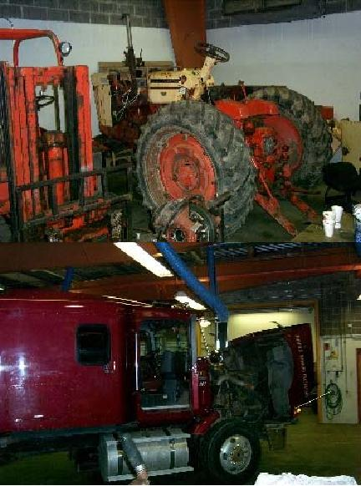

|  |  |  |
| --- | --- | --- |
| Mobile Units Repair – Trucks, Tractors, Dozers, etc. | | |
| *Step #* | *Energy Type* | **Shutdown Procedure** |
| 1 | electrical | All units in shop area will have a canister with LOTO applied to the  battery terminal |
| 2 | any/all | All units while in shop area will have ignition keys removed and hung on  key board in shop office |
| 3 | any/all | All units wheeled or tracked will be chalked with parking brake set to  prevent unwanted vehicle movement |
| 4 | any/all | Units with dump bodies or bodies that raise by cranking, by hand, or  hydraulically will be secured in the upright position with the safety stands  attached to their mountings while require service is performed |
| 5 | any/all | All units that articulate will have safety bars installed to prevent gravity or  hydraulically generated movement of the machine |
| 6 | any/all | All hydraulically controlled tractors, skidders, loaders and other  construction equipment will be parked with the hydraulic systems pressure  released. All implements lowered to the ground or into their safety stops |
| 7 | any/all | Perform required service according to manufacturer’s specs when available |
| 8 | any/all | Notify affected employees that the servicing or maintenance is complete  and the machine or equipment is ready for use |

|  |  |  |
| --- | --- | --- |
| ***Diesel Hydraulics Shop Exempt Equipment*** This includes all mobile and/or connected, single energy source devices | | |
| *Step #* | *Energy Type* | **Shutdown Procedure** |
| 1 | any/all | Remove plug from receptacle. |
| 2 | any/all | If service person does not have complete control of plug or has to leave device for any length of time place protective canister over plug. |
| 3 | any/all | Apply NMCC approved LOTO |
| 4 | any/all | Reverse procedure to verify proper operation. |

# ELECTRICAL CONSTRUCTION & MAINTENANCE

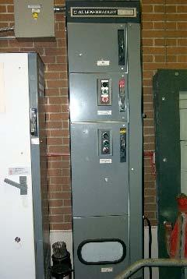

|  |  |  |
| --- | --- | --- |
| Allen Bradley MCC | | |
| *Step #* | *Energy Type* | **Shutdown Procedure** |
| 1 | any/all | Notify all affected employees of planned shutdown |
| 2 | any/all | Shut down equipment at operator’s controls |
| 3 | electrical | Move breaker #24 in panel PK to the “off” position |
| 4 | electrical | Apply NMCC approved LOTO to breaker #24 |
| 5 | electrical | Activate start button and measure voltage to verify the removal of energy  sources |
| 6 | any/all | Perform required service according to manufacturer’s specs when  available |

|  |  |  |
| --- | --- | --- |
| Allen Bradley MCC | | |
| *Step #* | *Energy Type* | **Startup Procedure** |
| 1 | any/all | Check for complete reassembly |
| 2 | any/all | Check equipment to insure complete removal of tools, repair materials, etc. |
| 3 | any/all | Replace all covers/guards |
| 4 | electrical | Remove LOTO from breaker #24 in panel PK |
| 5 | electrical | Move breaker #24 in panel PK to the “on” position |
| 6 | electrical | Activate start button to verify proper operation |
| 7 | any/all | Notify affected employees that the servicing or maintenance is complete and the machine or equipment is ready for use |

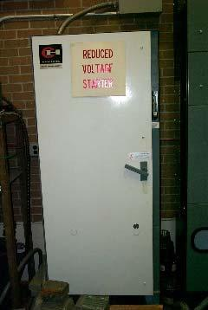

|  |  |  |
| --- | --- | --- |
| Cutler Hammer Drive | | |
| *Step #* | *Energy Type* | **Shutdown Procedure** |
| 1 | any/all | Notify all affected employees of planned shutdown |
| 2 | any/all | Shut down equipment at operator’s controls |
| 3 | electrical | Move breaker #24 in panel PK to the “off” position |
| 4 | electrical | Apply NMCC approved LOTO to breaker #24 |
| 5 | electrical | Activate start button and measure voltage to verify the removal of energy  sources |
| 6 | any/all | Perform required service according to manufacturer’s specs when  available |

|  |  |  |
| --- | --- | --- |
| Cutler Hammer Drive | | |
| *Step #* | *Energy Type* | **Startup Procedure** |
| 1 | any/all | Check for complete reassembly |
| 2 | any/all | Check equipment to insure complete removal of tools, repair materials, etc. |
| 3 | any/all | Replace all covers/guards |
| 4 | electrical | Remove LOTO from breaker #24 in panel PK |
| 5 | electrical | Move breaker #24 in panel PK to the “on” position |
| 6 | electrical | Activate start button to verify proper operation |
| 7 | any/all | Notify affected employees that the servicing or maintenance is complete and the machine or equipment is ready for use |

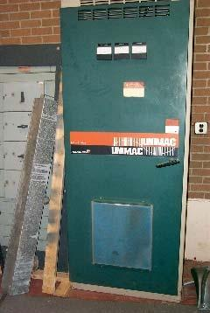

|  |  |  |
| --- | --- | --- |
| Reliance Drive | | |
| *Step #* | *Energy Type* | **Shutdown Procedure** |
| 1 | any/all | Notify all affected employees of planned shutdown |
| 2 | electrical | Move breaker #20 in panel PK to the “off” position |
| 3 | electrical | Apply NMCC approved LOTO to breaker #20 |
| 4 | electrical | Measure voltage on line side of main breaker inside equipment to verify  removal of power |
| 5 | any/all | Perform required service according to manufacturer’s specs when  available |

|  |  |  |
| --- | --- | --- |
| Reliance Drive | | |
| *Step #* | *Energy Type* | **Startup Procedure** |
| 1 | any/all | Check for complete reassembly |
| 2 | any/all | Check equipment to insure complete removal of tools, repair materials, etc. |
| 3 | any/all | Replace all covers/guards |
| 4 | electrical | Remove LOTO from breaker #20 in panel PK |
| 5 | electrical | Move breaker #24 in panel PK to the “on” position |
| 6 | electrical | Activate start button to verify proper operation |
| 7 | any/all | Notify affected employees that the servicing or maintenance is complete and the machine or equipment is ready for use |

|  |  |  |
| --- | --- | --- |
| ***Electrical Construction & Maintenance Shop Exempt Equipment*** This includes all mobile and/or connected, single energy source devices | | |
| *Step #* | *Energy Type* | **Shutdown Procedure** |
| 1 | any/all | Remove plug from receptacle. |
| 2 | any/all | If service person does not have complete control of plug or has to leave device for any length of time place protective canister over plug. |
| 3 | any/all | Apply NMCC approved LOTO |
| 4 | any/all | Reverse procedure to verify proper operation. |

# INDUSTRIAL CONTROL & MEASURMENT TECHNOLOGY

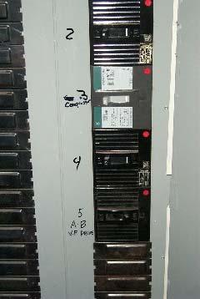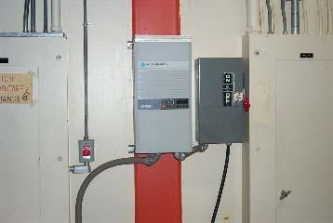

|  |  |  |
| --- | --- | --- |
| 25hp Variable Frequency Drive | | |
| *Step #* | *Energy Type* | **Shutdown Procedure** |
| 1 | any/all | Notify all affected employees of planned shutdown |
| 2 | any/all | Shut down equipment at operator’s controls |
| 3 | electrical | Move breaker #5 on panel P-F to the “off” position |
| 4 | electrical | Apply NMCC approved LOTO to breaker |
| 5 | electrical | Activate start button to verify the removal of power |
| 6 | any/all | Perform required service according to manufacturer’s specs when available |

|  |  |  |
| --- | --- | --- |
| 25hp Variable Frequency Drive | | |
| *Step #* | *Energy Type* | **Startup Procedure** |
| 1 | any/all | Check for complete reassembly |
| 2 | any/all | Check equipment to insure complete removal of tools, repair materials, etc. |
| 3 | any/all | Replace all covers/guards |
| 4 | electrical | Remove LOTO from breaker #5 on panel P-F |
| 5 | electrical | Move breaker #5 on panel P-F to the “on” position |
| 6 | air | Activate start button to verify proper operation |
| 7 | any/all | Notify affected employees that the servicing or maintenance is complete and the machine or equipment is ready for use |



|  |  |  |
| --- | --- | --- |
| VFD Motor | | |
| *Step #* | *Energy Type* | **Shutdown Procedure** |
| 1 | any/all | Notify all affected employees of planned shutdown |
| 2 | any/all | Shut down equipment at operator’s controls |
| 3 | electrical | Move disconnect on wall above motor to the “off” position |
| 4 | electrical | Apply NMCC approved LOTO to disconnect |
| 5 | electrical | Activate start button to verify the removal of power |
| 6 | any/all | Perform required service according to manufacturer’s specs when available |

|  |  |  |
| --- | --- | --- |
| VFD Motor | | |
| *Step #* | *Energy Type* | **Startup Procedure** |
| 1 | any/all | Check for complete reassembly |
| 2 | any/all | Check equipment to insure complete removal of tools, repair materials, etc. |
| 3 | any/all | Replace all covers/guards |
| 4 | electrical | Remove LOTO from breaker |
| 5 | electrical | Move breaker to the “on” position |
| 6 | air | Activate start button to verify proper operation |
| 7 | any/all | Notify affected employees that the servicing or maintenance is complete and the machine or equipment is ready for use |

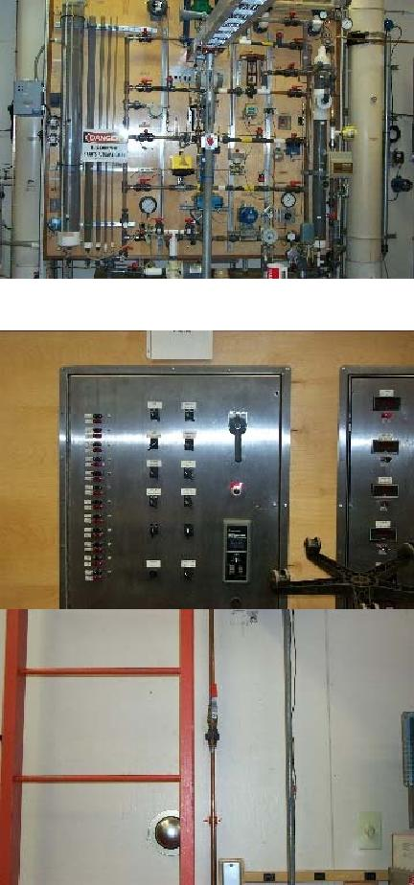

|  |  |  |
| --- | --- | --- |
| Process Control Trainer | | |
| *Step #* | *Energy Type* | **Shutdown Procedure** |
| 1 | any/all | Notify all affected employees of planned shutdown |
| 2 | any/all | Shutdown equipment by turning off all operator controls and power  distribution panel |
| 3 | electrical | Move disconnect on trainer to the “off” position |
| 4 | electrical | Apply NMCC approved LOTO to disconnect |
| 5 | air | Shut off air supply at main valve on trainer |
| 6 | air | Apply NMCC approved LOTO to main air valve |
| 7 | air/electrical | Verify that all air pressure gauges are reading 0 psi |
| 8 | any/all | Activate operator controls to verify removal of all energy sources |
| 9 | any/all | Perform required service according to manufacturer’s specs when  available |

|  |  |  |
| --- | --- | --- |
| Process Control Trainer | | |
| *Step #* | *Energy Type* | **Startup Procedure** |
| 1 | any/all | Check for complete reassembly |
| 2 | any/all | Check equipment to insure complete removal of tools, repair materials, etc. |
| 3 | any/all | Replace all covers/guards |
| 4 | electrical | Remove LOTO from trainer disconnect |
| 5 | electrical | Move disconnect to the “on” position |
| 6 | air | Remove LOTO from air supply valve |
| 7 | air | Open air supply valve |
| 8 | air/electric | Activate start button to verify proper operation |
| 9 | any/all | Notify affected employees that the servicing or maintenance is complete and the machine or equipment is ready for use |

|  |  |  |
| --- | --- | --- |
| ***Industrial Controls & Measurement Exempt Equipment*** This includes all mobile and/or connected, single energy source devices | | |
| *Step #* | *Energy Type* | **Shutdown Procedure** |
| 1 | any/all | Remove plug from receptacle. |
| 2 | any/all | If service person does not have complete control of plug or has to leave device for any length of time place protective canister over plug. |
| 3 | any/all | Apply NMCC approved LOTO |
| 4 | any/all | Reverse procedure to verify proper operation. |

PLUMBING & HEATING TECHNOLOGY

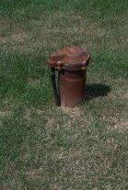

|  |  |  |
| --- | --- | --- |
| Submersible Pump | | |
| *Step #* | *Energy Type* | **Shutdown Procedure** |
| 1 | any/all | Notify all affected employees of planned shutdown |
| 2 | electrical | Move breaker #6 in Panel B-6 to the “off” position |
| 3 | electrical | Apply NMCC approved LOTO to breaker #6 in Panel B-6 |
| 4 | electrical | Measure voltage at pressure switch to verify the removal of power |
| 5 | any/all | Measure voltage splice in well casing |
| 6 | any/all | Perform required service according to manufacturer’s specs when  available |

|  |  |  |
| --- | --- | --- |
| Submersible Pump | | |
| *Step #* | *Energy Type* | **Startup Procedure** |
| 1 | any/all | Check for complete reassembly |
| 2 | any/all | Check equipment to insure complete removal of tools, repair materials, etc. |
| 3 | any/all | Replace all covers/guards |
| 4 | electrical | Remove LOTO from breaker #6 in panel B-6 |
| 5 | electrical | Move breaker #6 in panel B-6 to the “on” position |
| 6 | electrical | Activate to verify proper operation |
| 7 | any/all | Notify affected employees that the servicing or maintenance is complete and the machine or equipment is ready for use |

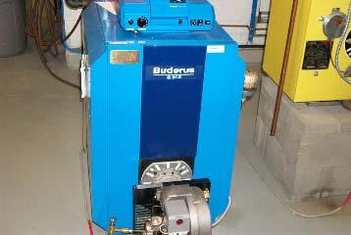

|  |  |  |
| --- | --- | --- |
| Water Boiler (Quantity 17) | | |
| *Step #* | *Energy Type* | **Shutdown Procedure** |
| 1 | any/all | Notify all affected employees of planned shutdown |
| 2 | any/all | Shutdown equipment at emergency (service) switch |
| 3 | electrical | Locate panel and breaker as identified on the side of Boiler and move to “off” position |
| 4 | electrical | Apply NMCC approved LOTO to breaker |
| 5 | hot water | Close valve to isolate boiler from system |
| 6 | hot water | Apply NMCC approved LOTO to valve |
| 7 | hot water | Let equipment cool |
| 8 | hot water | Open drain at bottom of boiler to remove hot water |
| 9 | any/all | Measure voltage at low water cutoff to verify the removal of power |
| 10 | any/all | Perform required services according to manufacturer’s specs when  available |

|  |  |  |
| --- | --- | --- |
| Water Boiler (Quantity 17) | | |
| *Step #* | *Energy Type* | **Startup Procedure** |
| 1 | any/all | Check for complete reassembly |
| 2 | any/all | Check equipment to insure complete removal of tools, repair materials, etc. |
| 3 | any/all | Replace all covers/guards |
| 4 | electrical | Close drain valve |
| 5 | electrical | Refill furnace with water |
| 6 | electrical | Remove LOTO from breaker |
| 7 | electrical | Move breaker to “on” position |
| 8 | any/all | Activate start button to verify proper operation |
| 9 | any/all | Notify affected employees that the servicing or maintenance is complete and the machine or equipment is ready for use |

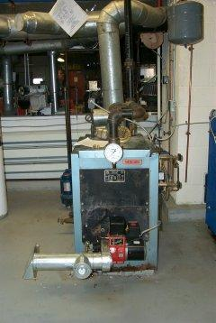

|  |  |  |
| --- | --- | --- |
| Steam Boiler | | |
| *Step #* | *Energy Type* | **Shutdown Procedure** |
| 1 | any/all | Notify all affected employees of planned shutdown |
| 2 | any/all | Shutdown equipment at emergency (service) switch |
| 3 | electrical | Move circuit breaker #1 in panel #24 to the “off” position |
| 4 | electrical | Apply NMCC approved LOTO to breaker #1 in panel #24 |
| 5 | steam | Close valve to isolate boiler from system |
| 6 | steam | Apply NMCC approved LOTO to valve |
| 7 | steam | Open drain at bottom of boiler to remove steam |
| 8 | any/all | Measure voltages at low water cutoff to verify the removal of power |
| 9 | any/all | Perform required services according to manufacturer’s specs when  available |

|  |  |  |
| --- | --- | --- |
| Steam Boiler | | |
| *Step #* | *Energy Type* | **Startup Procedure** |
| 1 | any/all | Check for complete reassembly |
| 2 | any/all | Check equipment to insure complete removal of tools, repair materials, etc. |
| 3 | any/all | Replace all covers/guards |
| 4 | hydraulic | Close drain valve |
| 5 | hydraulic | Refill furnace with water |
| 6 | electrical | Remove LOTO from breaker #1 in panel #24 |
| 7 | electrical | Move breaker #1 in panel #24 to “on” position |
| 8 | any/all | Activate start button to verify proper operation |
| 9 | any/all | Notify affected employees that the servicing or maintenance is complete and the machine or equipment is ready for use |

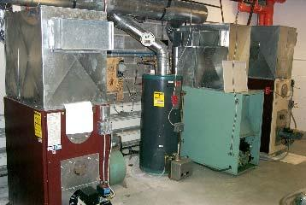

|  |  |  |
| --- | --- | --- |
| Warm Air Furnace (Quantity 8) | | |
| *Step #* | *Energy Type* | **Shutdown Procedure** |
| 1 | any/all | Notify all affected employees of planned shutdown |
| 2 | any/all | Shutdown equipment at emergency (service) switch |
| 3 | electrical | Locate panel and breaker as identified on the side of furnace and move to “off” position |
| 4 | electrical | Apply NMCC approved LOTO to breaker |
| 5 | electrical | Activate Emergency (Service) switch and measure voltages at fan/limit  switch to verify removal of power |
| 6 | any/all | Perform required service according to manufacturer’s specs when  available |

|  |  |  |
| --- | --- | --- |
| Warm Air Furnace (Quantity 8) | | |
| *Step #* | *Energy Type* | **Startup Procedure** |
| 1 | any/all | Check for complete reassembly |
| 2 | any/all | Check equipment to insure complete removal of tools, repair materials, etc. |
| 3 | any/all | Replace all covers/guards |
| 4 | electrical | Remove LOTO from breaker |
| 5 | electrical | Move breaker to “on” position |
| 6 | electrical | Activate start button to verify proper operation |
| 7 | any/all | Notify affected employees that the servicing or maintenance is complete and the machine or equipment is ready for use |

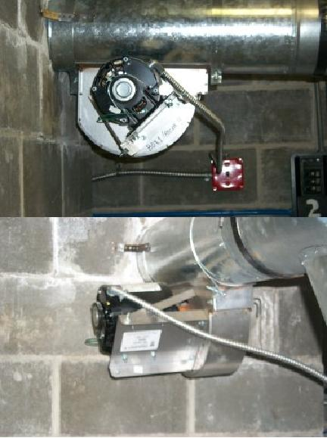

|  |  |  |
| --- | --- | --- |
| Draft Booster (Quantity 4) | | |
| *Step #* | *Energy Type* | **Shutdown Procedure** |
| 1 | any/all | Notify all affected employees of planned shutdown |
| 2 | any/all | Shutdown equipment at emergency (service) switch |
| 3 | electrical | Locate panel and breaker as identified on the side of furnace and move to “off” position |
| 4 | electrical | Apply NMCC approved LOTO to breaker |
| 5 | electrical | Activate Emergency (Service) switch and measure voltages at fan/limit  switch to verify removal of power |
| 6 | any/all | Perform required service according to manufacturer’s specs when  available |

|  |  |  |
| --- | --- | --- |
| Draft Booster (Quantity 4) | | |
| *Step #* | *Energy Type* | **Startup Procedure** |
| 1 | any/all | Check for complete reassembly |
| 2 | any/all | Check equipment to insure complete removal of tools, repair materials, etc. |
| 3 | any/all | Replace all covers/guards |
| 4 | electrical | Remove LOTO from breaker |
| 5 | electrical | Move breaker to “on” position |
| 6 | electrical | Activate start button to verify proper operation |
| 7 | any/all | Notify affected employees that the servicing or maintenance is complete and the machine or equipment is ready for use |

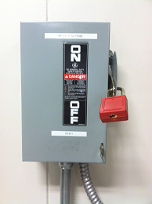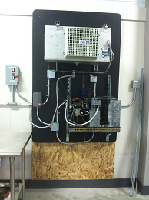

|  |  |  |
| --- | --- | --- |
| Refrigeration Test Station #1 | | |
| *Step #* | *Energy Type* | **Shutdown Procedure** |
| 1 | any/all | Notify all affected employees of planned shutdown |
| 2 | any/all | Shutdown equipment operator controls |
| 3 | electrical | Move breaker to the “off” position |
| 4 | electrical | Apply NMCC approved LOTO to Panel P3, breaker 9 & 11 |
| 5 | electrical | Activate operator controls to verify all energy sources are removed |
| 6 | any/all | Perform required service according to manufacturer’s specs when  available |

|  |  |  |
| --- | --- | --- |
| Refrigeration Test Station #1 | | |
| *Step #* | *Energy Type* | **Startup Procedure** |
| 1 | any/all | Check for complete reassembly |
| 2 | any/all | Check equipment to insure complete removal of tools, repair materials, etc. |
| 3 | any/all | Replace all covers/guards |
| 4 | electrical | Remove LOTO from breaker |
| 5 | electrical | Activate start button to verify proper operation |
| 6 | any/all | Notify affected employees that the servicing or maintenance is complete  and the machine or equipment is ready for use |

***Procedure does not include refrigerator system***

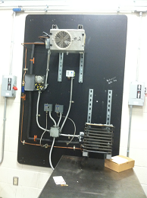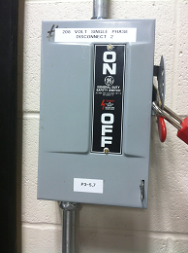

|  |  |  |
| --- | --- | --- |
| Refrigeration Test Station #2 | | |
| *Step #* | *Energy Type* | **Shutdown Procedure** |
| 1 | any/all | Notify all affected employees of planned shutdown |
| 2 | any/all | Shutdown equipment operator controls |
| 3 | electrical | Move breaker to the “off” position |
| 4 | electrical | Apply NMCC approved LOTO to Panel P3, breaker 5 & 7 |
| 5 | electrical | Activate operator controls to verify all energy sources are removed |
| 6 | any/all | Perform required service according to manufacturer’s specs when  available |

|  |  |  |
| --- | --- | --- |
| Refrigeration Test Station #2 | | |
| *Step #* | *Energy Type* | **Startup Procedure** |
| 1 | any/all | Check for complete reassembly |
| 2 | any/all | Check equipment to insure complete removal of tools, repair materials, etc. |
| 3 | any/all | Replace all covers/guards |
| 4 | electrical | Remove LOTO from breaker |
| 5 | electrical | Activate start button to verify proper operation |
| 6 | any/all | Notify affected employees that the servicing or maintenance is complete  and the machine or equipment is ready for use |

***Procedure does not include refrigerator system***

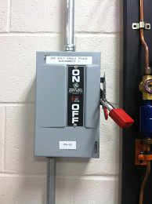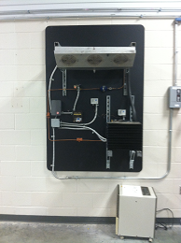

|  |  |  |
| --- | --- | --- |
| Refrigeration Test Station #3 | | |
| *Step #* | *Energy Type* | **Shutdown Procedure** |
| 1 | any/all | Notify all affected employees of planned shutdown |
| 2 | any/all | Shutdown equipment operator controls |
| 3 | electrical | Move breaker to the “off” position |
| 4 | electrical | Apply NMCC approved LOTO to Panel P3, breaker 1 & 3 |
| 5 | electrical | Activate operator controls to verify all energy sources are removed |
| 6 | any/all | Perform required service according to manufacturer’s specs when  available |

|  |  |  |
| --- | --- | --- |
| Refrigeration Test Station #3 | | |
| *Step #* | *Energy Type* | **Startup Procedure** |
| 1 | any/all | Check for complete reassembly |
| 2 | any/all | Check equipment to insure complete removal of tools, repair materials, etc. |
| 3 | any/all | Replace all covers/guards |
| 4 | electrical | Remove LOTO from breaker |
| 5 | electrical | Activate start button to verify proper operation |
| 6 | any/all | Notify affected employees that the servicing or maintenance is complete  and the machine or equipment is ready for use |

***Procedure does not include refrigerator system***

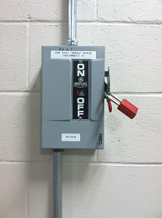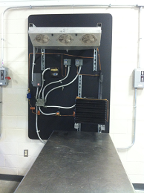

|  |  |  |
| --- | --- | --- |
| Refrigeration Test Station #4 | | |
| *Step #* | *Energy Type* | **Shutdown Procedure** |
| 1 | any/all | Notify all affected employees of planned shutdown |
| 2 | any/all | Shutdown equipment operator controls |
| 3 | electrical | Move breaker to the “off” position |
| 4 | electrical | Apply NMCC approved LOTO to Panel P3, breaker 13 & 15 |
| 5 | electrical | Activate operator controls to verify all energy sources are removed |
| 6 | any/all | Perform required service according to manufacturer’s specs when  available |

|  |  |  |
| --- | --- | --- |
| Refrigeration Test Station #4 | | |
| *Step #* | *Energy Type* | **Startup Procedure** |
| 1 | any/all | Check for complete reassembly |
| 2 | any/all | Check equipment to insure complete removal of tools, repair materials, etc. |
| 3 | any/all | Replace all covers/guards |
| 4 | electrical | Remove LOTO from breaker |
| 5 | electrical | Activate start button to verify proper operation |
| 6 | any/all | Notify affected employees that the servicing or maintenance is complete  and the machine or equipment is ready for use |

***Procedure does not include refrigerator system***

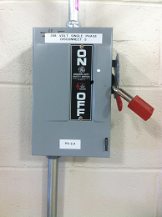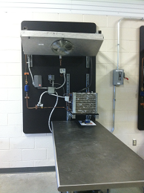

|  |  |  |
| --- | --- | --- |
| Refrigeration Test Station #5 | | |
| *Step #* | *Energy Type* | **Shutdown Procedure** |
| 1 | any/all | Notify all affected employees of planned shutdown |
| 2 | any/all | Shutdown equipment operator controls |
| 3 | electrical | Move breaker to the “off” position |
| 4 | electrical | Apply NMCC approved LOTO to Panel P3, breaker 2 & 4 |
| 5 | electrical | Activate operator controls to verify all energy sources are removed |
| 6 | any/all | Perform required service according to manufacturer’s specs when  available |

|  |  |  |
| --- | --- | --- |
| Refrigeration Test Station #5 | | |
| *Step #* | *Energy Type* | **Startup Procedure** |
| 1 | any/all | Check for complete reassembly |
| 2 | any/all | Check equipment to insure complete removal of tools, repair materials, etc. |
| 3 | any/all | Replace all covers/guards |
| 4 | electrical | Remove LOTO from breaker |
| 5 | electrical | Activate start button to verify proper operation |
| 6 | any/all | Notify affected employees that the servicing or maintenance is complete  and the machine or equipment is ready for use |

***Procedure does not include refrigerator system***

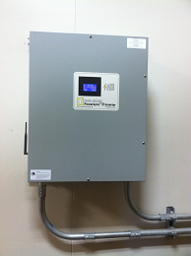

|  |  |  |
| --- | --- | --- |
| Wind Generator | | |
| *Step #* | *Energy Type* | **Shutdown Procedure** |
| 1 | any/all | Notify all affected employees of planned shutdown |
| 2 | any/all | Shutdown equipment operator controls |
| 3 | electrical | Move breaker to the “off” position |
| 4 | electrical | Apply NMCC approved LOTO to Panel P1, breaker 38 & 40 |
| 5 | electrical | Activate operator controls to verify all energy sources are removed |
| 6 | any/all | Perform required service according to manufacturer’s specs when  available |

|  |  |  |
| --- | --- | --- |
| Wind Generator | | |
| *Step #* | *Energy Type* | **Startup Procedure** |
| 1 | any/all | Check for complete reassembly |
| 2 | any/all | Check equipment to insure complete removal of tools, repair materials, etc. |
| 3 | any/all | Replace all covers/guards |
| 4 | electrical | Remove LOTO from breaker |
| 5 | electrical | Activate start button to verify proper operation |
| 6 | any/all | Notify affected employees that the servicing or maintenance is complete  and the machine or equipment is ready for use |

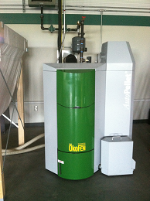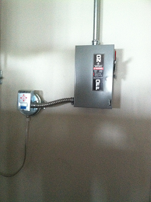

|  |  |  |
| --- | --- | --- |
| Okofen Pellet Boiler | | |
| *Step #* | *Energy Type* | **Shutdown Procedure** |
| 1 | any/all | Notify all affected employees of planned shutdown |
| 2 | any/all | Shutdown equipment at emergency (service) switch |
| 3 | electrical | Locate panel and breaker as identified on the side of Boiler and move to “off” position |
| 4 | electrical | Apply NMCC approved LOTO to breaker 11, 13, 27 & 23 |
| 5 | hot water | Close valve to isolate boiler from system |
| 6 | hot water | Apply NMCC approved LOTO to valve |
| 7 | hot water | Let equipment cool |
| 8 | hot water | Open drain at bottom of boiler to remove hot water |
| 9 | any/all | Measure voltage at low water cutoff to verify the removal of power |
| 10 | any/all | Perform required service according to manufacturer’s specs when  available |

|  |  |  |
| --- | --- | --- |
| Okofen Pellet Boiler | | |
| *Step #* | *Energy Type* | **Startup Procedure** |
| 1 | any/all | Check for complete reassembly |
| 2 | any/all | Check equipment to insure complete removal of tools, repair materials, etc. |
| 3 | any/all | Replace all covers/guards |
| 4 | hydraulic | Close drain valve |
| 5 | hydraulic | Refill furnace with water |
| 6 | electrical | Remove LOTO from breaker |
| 7 | electrical | Move breaker to “on” position |
| 8 | any/all | Activate start button to verify proper operation |
| 9 | any/all | Notify affected employees that the servicing or maintenance is complete  and the machine or equipment is ready for use |

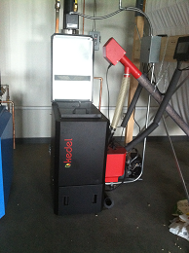

|  |  |  |
| --- | --- | --- |
| Kedel Pellet Boiler | | |
| *Step #* | *Energy Type* | **Shutdown Procedure** |
| 1 | any/all | Notify all affected employees of planned shutdown |
| 2 | any/all | Shutdown equipment at emergency (service) switch |
| 3 | electrical | Locate panel and breaker as identified on the side of Boiler and move to “off” position |
| 4 | electrical | Apply NMCC approved LOTO to breaker 7, 9, 22 & 23 |
| 5 | hot water | Close valve to isolate boiler from system |
| 6 | hot water | Apply NMCC approved LOTO to valve |
| 7 | hot water | Let equipment cool |
| 8 | hot water | Open drain at bottom of boiler to remove hot water |
| 9 | any/all | Measure voltage at low water cutoff to verify the removal of power |
| 10 | any/all | Perform required service according to manufacturer’s specs when  available |

|  |  |  |
| --- | --- | --- |
| Kedel Pellet Boiler | | |
| *Step #* | *Energy Type* | **Startup Procedure** |
| 1 | any/all | Check for complete reassembly |
| 2 | any/all | Check equipment to insure complete removal of tools, repair materials, etc. |
| 3 | any/all | Replace all covers/guards |
| 4 | hydraulic | Close drain valve |
| 5 | hydraulic | Refill furnace with water |
| 6 | electrical | Remove LOTO from breaker |
| 7 | electrical | Move breaker to “on” position |
| 8 | any/all | Activate start button to verify proper operation |
| 9 | any/all | Notify affected employees that the servicing or maintenance is complete  and the machine or equipment is ready for use |

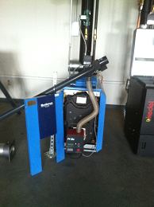

|  |  |  |
| --- | --- | --- |
| Bunderus Pellet Boiler | | |
| *Step #* | *Energy Type* | **Shutdown Procedure** |
| 1 | any/all | Notify all affected employees of planned shutdown |
| 2 | any/all | Shutdown equipment at emergency (service) switch |
| 3 | electrical | Locate panel and breaker as identified on the side of Boiler and move to “off” position |
| 4 | electrical | Apply NMCC approved LOTO to breaker 3, 5, 22 & 23 |
| 5 | hot water | Close valve to isolate boiler from system |
| 6 | hot water | Apply NMCC approved LOTO to valve |
| 7 | hot water | Let equipment cool |
| 8 | hot water | Open drain at bottom of boiler to remove hot water |
| 9 | any/all | Measure voltage at low water cutoff to verify the removal of power |
| 10 | any/all | Perform required service according to manufacturer’s specs when  available |

|  |  |  |
| --- | --- | --- |
| Bunderus Pellet Boiler | | |
| *Step #* | *Energy Type* | **Startup Procedure** |
| 1 | any/all | Check for complete reassembly |
| 2 | any/all | Check equipment to insure complete removal of tools, repair materials, etc. |
| 3 | any/all | Replace all covers/guards |
| 4 | hydraulic | Close drain valve |
| 5 | hydraulic | Refill furnace with water |
| 6 | electrical | Remove LOTO from breaker |
| 7 | electrical | Move breaker to “on” position |
| 8 | any/all | Activate start button to verify proper operation |
| 9 | any/all | Notify affected employees that the servicing or maintenance is complete  and the machine or equipment is ready for use |

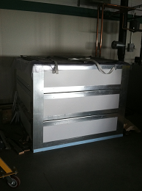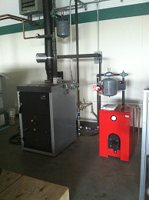

|  |  |  |
| --- | --- | --- |
| Biasi Pellet Boiler | | |
| *Step #* | *Energy Type* | **Shutdown Procedure** |
| 1 | any/all | Notify all affected employees of planned shutdown |
| 2 | any/all | Shutdown equipment at emergency (service) switch |
| 3 | electrical | Locate panel and breaker as identified on the side of Boiler and move to “off” position |
| 4 | electrical | Apply NMCC approved LOTO to breaker 25, 22 & 23 |
| 5 | hot water | Close valve to isolate boiler from system |
| 6 | hot water | Apply NMCC approved LOTO to valve |
| 7 | hot water | Let equipment cool |
| 8 | hot water | Open drain at bottom of boiler to remove hot water |
| 9 | any/all | Measure voltage at low water cutoff to verify the removal of power |
| 10 | any/all | Perform required service according to manufacturer’s specs when  available |

|  |  |  |
| --- | --- | --- |
| Biasi Pellet Boiler | | |
| *Step #* | *Energy Type* | **Startup Procedure** |
| 1 | any/all | Check for complete reassembly |
| 2 | any/all | Check equipment to insure complete removal of tools, repair materials, etc. |
| 3 | any/all | Replace all covers/guards |
| 4 | hydraulic | Close drain valve |
| 5 | hydraulic | Refill furnace with water |
| 6 | electrical | Remove LOTO from breaker |
| 7 | electrical | Move breaker to “on” position |
| 8 | any/all | Activate start button to verify proper operation |
| 9 | any/all | Notify affected employees that the servicing or maintenance is complete  and the machine or equipment is ready for use |

|  |  |  |
| --- | --- | --- |
| ***Plumbing & Heating Shop Exempt Equipment*** This includes all mobile and/or connected, single energy source devices | | |
| *Step #* | *Energy Type* | **Shutdown Procedure** |
| 1 | any/all | Remove plug from receptacle. |
| 2 | any/all | If service person does not have complete control of plug or has to leave device for any length of time place protective canister over plug. |
| 3 | any/all | Apply NMCC approved LOTO |
| 4 | any/all | Reverse procedure to verify proper operation. |

# PRECISION MACHINING

# &

# COMPUTER NUMERICAL CONTROLS

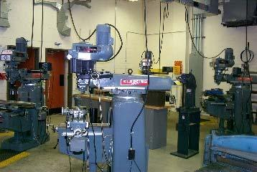

|  |  |  |
| --- | --- | --- |
| Clausing Vertical Mill #1 | | |
| *Step #* | *Energy Type* | **Shutdown Procedure** |
| 1 | any/all | Notify all affected employees of planned shutdown |
| 2 | any/all | Shutdown Tool Head, Power feed, and Digital Readout |
| 3 | electrical | Turn off Bus A breaker in Panel B |
| 4 | electrical | Apply NMCC approved LOTO to Bus A breaker in Panel B |
| 5 | electrical | Disconnect cord/plug on Power Feed |
| 6 | electrical | Apply canister to Power Feed cord/plug |
| 7 | electrical | Apply NMCC approved LOTO to canister |
| 8 | any/all | Disconnect cord/plug on Digital Readout |
| 9 | electrical | Apply canister to cord/plug on Digital Readout |
| 10 | electrical | Apply NMCC approved LOTO to canister |
| 11 | electrical | Activate power switch to verify removal of energy from Tool Head, Power  Feed and Digital Readout |
| 12 | any/all | Perform required service according to manufacturer’s specs when  available |

|  |  |  |
| --- | --- | --- |
| Clausing Vertical Mill #1 | | |
| *Step #* | *Energy Type* | **Startup Procedure** |
| 1 | any/all | Check for complete reassembly |
| 2 | any/all | Check equipment to insure complete removal of tools, repair materials, etc. |
| 3 | any/all | Replace all covers/guards |
| 4 | electrical | Remove LOTO from all canisters |
| 5 | electrical | Connect cord/plug on Power Feed and Digital Readout |
| 6 | air | Remove LOTO from Bus A breaker in Panel B |
| 7 | air | Turn on Bus A breaker in Panel B |
| 8 | air/electric | Activate power switch to verify proper operation |
| 9 | any/all | Notify affected employees that the servicing or maintenance is complete and the machine or equipment is ready for use |

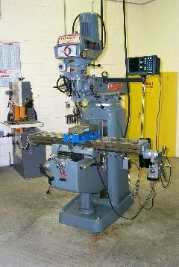

|  |  |  |
| --- | --- | --- |
| Clausing Vertical Mill #2 | | |
| *Step #* | *Energy Type* | **Shutdown Procedure** |
| 1 | any/all | Notify all affected employees of planned shutdown |
| 2 | any/all | Shutdown Tool Head, Power feed, and Digital Readout |
| 3 | electrical | Turn off Bus A breaker in Panel B |
| 4 | electrical | Apply NMCC approved LOTO to Bus A breaker in Panel B |
| 5 | electrical | Disconnect cord/plug on Power Feed |
| 6 | electrical | Apply canister to Power Feed cord/plug |
| 7 | electrical | Apply NMCC approved LOTO to canister |
| 8 | any/all | Disconnect cord/plug on Digital Readout |
| 9 | electrical | Apply canister to cord/plug on Digital Readout |
| 10 | electrical | Apply NMCC approved LOTO to canister |
| 11 | electrical | Activate power switch to verify removal of energy from Tool Head, Power  Feed and Digital Readout |
| 12 | any/all | Perform required service according to manufacturer’s specs when  available |

|  |  |  |
| --- | --- | --- |
| Clausing Vertical Mill #2 | | |
| *Step #* | *Energy Type* | **Startup Procedure** |
| 1 | any/all | Check for complete reassembly |
| 2 | any/all | Check equipment to insure complete removal of tools, repair materials, etc. |
| 3 | any/all | Replace all covers/guards |
| 4 | electrical | Remove LOTO from all canisters |
| 5 | electrical | Connect cord/plug on Power Feed and Digital Readout |
| 6 | air | Remove LOTO from Bus A breaker in Panel B |
| 7 | air | Turn on Bus A breaker in Panel B |
| 8 | air/electric | Activate power switch to verify proper operation |
| 9 | any/all | Notify affected employees that the servicing or maintenance is complete and the machine or equipment is ready for use |

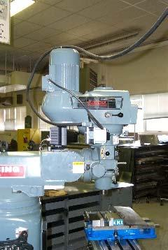

|  |  |  |
| --- | --- | --- |
| Clausing Vertical Mill #3 | | |
| *Step #* | *Energy Type* | **Shutdown Procedure** |
| 1 | any/all | Notify all affected employees of planned shutdown |
| 2 | any/all | Shutdown Tool Head, Power feed, and Digital Readout |
| 3 | electrical | Turn off Bus A breaker in Panel B |
| 4 | electrical | Apply NMCC approved LOTO to Bus A breaker in Panel B |
| 5 | electrical | Disconnect cord/plug on Power Feed |
| 6 | electrical | Apply canister to Power Feed cord/plug |
| 7 | electrical | Apply NMCC approved LOTO to canister |
| 8 | any/all | Disconnect cord/plug on Digital Readout |
| 9 | electrical | Apply canister to cord/plug on Digital Readout |
| 10 | electrical | Apply NMCC approved LOTO to canister |
| 11 | electrical | Activate power switch to verify removal of energy from Tool Head, Power  Feed and Digital Readout |
| 12 | any/all | Perform required service according to manufacturer’s specs when  available |

|  |  |  |
| --- | --- | --- |
| Clausing Vertical Mill #3 | | |
| *Step #* | *Energy Type* | **Startup Procedure** |
| 1 | any/all | Check for complete reassembly |
| 2 | any/all | Check equipment to insure complete removal of tools, repair materials, etc. |
| 3 | any/all | Replace all covers/guards |
| 4 | electrical | Remove LOTO from all canisters |
| 5 | electrical | Connect cord/plug on Power Feed and Digital Readout |
| 6 | air | Remove LOTO from Bus A breaker in Panel B |
| 7 | air | Turn on Bus A breaker in Panel B |
| 8 | air/electric | Activate power switch to verify proper operation |
| 9 | any/all | Notify affected employees that the servicing or maintenance is complete and the machine or equipment is ready for use |

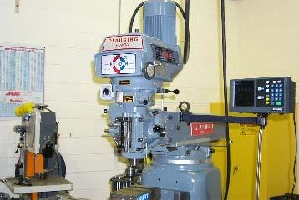

|  |  |  |
| --- | --- | --- |
| Clausing Vertical Mill #4 | | |
| *Step #* | *Energy Type* | **Shutdown Procedure** |
| 1 | any/all | Notify all affected employees of planned shutdown |
| 2 | any/all | Shutdown Tool Head, Power feed, and Digital Readout |
| 3 | electrical | Turn off Bus A breaker in Panel B |
| 4 | electrical | Apply NMCC approved LOTO to Bus A breaker in Panel B |
| 5 | electrical | Disconnect cord/plug on Power Feed |
| 6 | electrical | Apply canister to Power Feed cord/plug |
| 7 | electrical | Apply NMCC approved LOTO to canister |
| 8 | any/all | Disconnect cord/plug on Digital Readout |
| 9 | electrical | Apply canister to cord/plug on Digital Readout |
| 10 | electrical | Apply NMCC approved LOTO to canister |
| 11 | electrical | Activate power switch to verify removal of energy from Tool Head, Power  Feed and Digital Readout |
| 12 | any/all | Perform required service according to manufacturer’s specs when  available |

|  |  |  |
| --- | --- | --- |
| Clausing Vertical Mill #4 | | |
| *Step #* | *Energy Type* | **Startup Procedure** |
| 1 | any/all | Check for complete reassembly |
| 2 | any/all | Check equipment to insure complete removal of tools, repair materials, etc. |
| 3 | any/all | Replace all covers/guards |
| 4 | electrical | Remove LOTO from all canisters |
| 5 | electrical | Connect cord/plug on Power Feed and Digital Readout |
| 6 | air | Remove LOTO from Bus A breaker in Panel B |
| 7 | air | Turn on Bus A breaker in Panel B |
| 8 | air/electric | Activate power switch to verify proper operation |
| 9 | any/all | Notify affected employees that the servicing or maintenance is complete and the machine or equipment is ready for use |



|  |  |  |
| --- | --- | --- |
| Acer E-Mill Vertical Mill #5 | | |
| *Step #* | *Energy Type* | **Shutdown Procedure** |
| 1 | any/all | Notify all affected employees of planned shutdown |
| 2 | any/all | Shutdown Tool Head, Power feed, and Digital Readout |
| 3 | electrical | Turn off Bus A breaker in Panel B |
| 4 | electrical | Apply NMCC approved LOTO to CRKT 1, 3, 5 |
| 5 | electrical | Disconnect cord/plug on Power Feed |
| 6 | electrical | Apply canister to Power Feed cord/plug |
| 7 | electrical | Apply NMCC approved LOTO to canister |
| 8 | any/all | Disconnect cord/plug on Digital Readout |
| 9 | electrical | Apply canister to cord/plug on Digital Readout |
| 10 | electrical | Apply NMCC approved LOTO to canister |
| 11 | electrical | Activate power switch to verify removal of energy from Tool Head, Power  Feed and Digital Readout |
| 12 | any/all | Perform required service according to manufacturer’s specs when  available |

|  |  |  |
| --- | --- | --- |
| Acer E-Mill Vertical Mill #5 | | |
| *Step #* | *Energy Type* | **Startup Procedure** |
| 1 | any/all | Check for complete reassembly |
| 2 | any/all | Check equipment to insure complete removal of tools, repair materials, etc. |
| 3 | any/all | Replace all covers/guards |
| 4 | electrical | Remove LOTO from all canisters |
| 5 | electrical | Connect cord/plug on Power Feed and Digital Readout |
| 6 | air | Remove LOTO from Bus A breaker in Panel B |
| 7 | air | Turn on Bus A breaker in Panel B |
| 8 | air/electric | Activate power switch to verify proper operation |
| 9 | any/all | Notify affected employees that the servicing or maintenance is complete and the machine or equipment is ready for use |

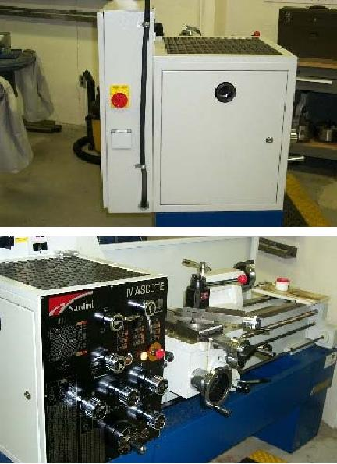

|  |  |  |
| --- | --- | --- |
| Nardini Dynamic 1400 G Engine Lathe #1 | | |
| *Step #* | *Energy Type* | **Shutdown Procedure** |
| 1 | any/all | Notify all affected employees of planned shutdown |
| 2 | any/all | Shutdown equipment at main switch |
| 3 | electrical | Turn off Bus A breaker in Panel B |
| 4 | electrical | Apply NMCC approved LOTO to breaker |
| 5 | electrical | Disconnect cord/plug on Digital Readout |
| 6 | electrical | Apply canister to Digital Readout cord/plug |
| 7 | electrical | Apply NMCC approved LOTO to canister |
| 8 | any/all | Place operator switch in either the I or II position. Check to make sure the  emergency stop button is not depressed. |
| 9 | any/all | Place the chuck guard into the operating position and remove the FWD/RVS lever to verify that all energy sources have been removed. |
| 10 | any/all | Perform required service according to manufacturer’s specs when  available |

|  |  |  |
| --- | --- | --- |
| Nardini Dynamic 1400 G Engine Lathe #1 | | |
| *Step #* | *Energy Type* | **Startup Procedure** |
| 1 | any/all | Check for complete reassembly |
| 2 | any/all | Check equipment to insure complete removal of tools, repair materials, etc. |
| 3 | any/all | Replace all covers/guards |
| 4 | electrical | Remove LOTO from all canisters |
| 5 | electrical | Remove canister from Digital Readout cord/plug |
| 6 | electrical | Reconnect Digital Readout cord/plug |
| 7 | electrical | Remove LOTO from Bus B breaker in Panel B |
| 8 | electrical | Turn on equipment at main switch to verify proper operation |
| 9 | any/all | Notify affected employees that the servicing or maintenance is complete and the machine or equipment is ready for use |



|  |  |  |
| --- | --- | --- |
| Nardini Dynamic 1400 G Engine Lathe #2 | | |
| *Step #* | *Energy Type* | **Shutdown Procedure** |
| 1 | any/all | Notify all affected employees of planned shutdown |
| 2 | any/all | Shutdown equipment at main switch |
| 3 | electrical | Turn off Bus A breaker in Panel B |
| 4 | electrical | Apply NMCC approved LOTO to breaker |
| 5 | electrical | Disconnect cord/plug on Digital Readout |
| 6 | electrical | Apply canister to Digital Readout cord/plug |
| 7 | electrical | Apply NMCC approved LOTO to canister |
| 8 | any/all | Place operator switch in either the I or II position. Check to make sure the  emergency stop button is not depressed. |
| 9 | any/all | Place the chuck guard into the operating position and remove the FWD/RVS lever to verify that all energy sources have been removed. |
| 10 | any/all | Perform required service according to manufacturer’s specs when  available |

|  |  |  |
| --- | --- | --- |
| Nardini Dynamic 1400 G Engine Lathe #2 | | |
| *Step #* | *Energy Type* | **Startup Procedure** |
| 1 | any/all | Check for complete reassembly |
| 2 | any/all | Check equipment to insure complete removal of tools, repair materials, etc. |
| 3 | any/all | Replace all covers/guards |
| 4 | electrical | Remove LOTO from all canisters |
| 5 | electrical | Remove canister from Digital Readout cord/plug |
| 6 | electrical | Reconnect Digital Readout cord/plug |
| 7 | electrical | Remove LOTO from Bus B breaker in Panel B |
| 8 | electrical | Turn on equipment at main switch to verify proper operation |
| 9 | any/all | Notify affected employees that the servicing or maintenance is complete and the machine or equipment is ready for use |



|  |  |  |
| --- | --- | --- |
| Nardini Dynamic 1400 G Engine Lathe #3 | | |
| *Step #* | *Energy Type* | **Shutdown Procedure** |
| 1 | any/all | Notify all affected employees of planned shutdown |
| 2 | any/all | Shutdown equipment at main switch |
| 3 | electrical | Turn off Bus A breaker in Panel B |
| 4 | electrical | Apply NMCC approved LOTO to breaker |
| 5 | electrical | Disconnect cord/plug on Digital Readout |
| 6 | electrical | Apply canister to Digital Readout cord/plug |
| 7 | electrical | Apply NMCC approved LOTO to canister |
| 8 | any/all | Place operator switch in either the I or II position. Check to make sure the  emergency stop button is not depressed. |
| 9 | any/all | Place the chuck guard into the operating position and remove the FWD/RVS lever to verify that all energy sources have been removed. |
| 10 | any/all | Perform required service according to manufacturer’s specs when  available |

|  |  |  |
| --- | --- | --- |
| Nardini Dynamic 1400 G Engine Lathe #3 | | |
| *Step #* | *Energy Type* | **Startup Procedure** |
| 1 | any/all | Check for complete reassembly |
| 2 | any/all | Check equipment to insure complete removal of tools, repair materials, etc. |
| 3 | any/all | Replace all covers/guards |
| 4 | electrical | Remove LOTO from all canisters |
| 5 | electrical | Remove canister from Digital Readout cord/plug |
| 6 | electrical | Reconnect Digital Readout cord/plug |
| 7 | electrical | Remove LOTO from Bus B breaker in Panel B |
| 8 | electrical | Turn on equipment at main switch to verify proper operation |
| 9 | any/all | Notify affected employees that the servicing or maintenance is complete and the machine or equipment is ready for use |



|  |  |  |
| --- | --- | --- |
| Nardini Dynamic 1400 G Engine Lathe #4 | | |
| *Step #* | *Energy Type* | **Shutdown Procedure** |
| 1 | any/all | Notify all affected employees of planned shutdown |
| 2 | any/all | Shutdown equipment at main switch |
| 3 | electrical | Turn off Bus A breaker in Panel B |
| 4 | electrical | Apply NMCC approved LOTO to breaker |
| 5 | electrical | Disconnect cord/plug on Digital Readout |
| 6 | electrical | Apply canister to Digital Readout cord/plug |
| 7 | electrical | Apply NMCC approved LOTO to canister |
| 8 | any/all | Place operator switch in either the I or II position. Check to make sure the  emergency stop button is not depressed. |
| 9 | any/all | Place the chuck guard into the operating position and remove the FWD/RVS lever to verify that all energy sources have been removed. |
| 10 | any/all | Perform required service according to manufacturer’s specs when  available |

|  |  |  |
| --- | --- | --- |
| Nardini Dynamic 1400 G Engine Lathe #4 | | |
| *Step #* | *Energy Type* | **Startup Procedure** |
| 1 | any/all | Check for complete reassembly |
| 2 | any/all | Check equipment to insure complete removal of tools, repair materials, etc. |
| 3 | any/all | Replace all covers/guards |
| 4 | electrical | Remove LOTO from all canisters |
| 5 | electrical | Remove canister from Digital Readout cord/plug |
| 6 | electrical | Reconnect Digital Readout cord/plug |
| 7 | electrical | Remove LOTO from Bus B breaker in Panel B |
| 8 | electrical | Turn on equipment at main switch to verify proper operation |
| 9 | any/all | Notify affected employees that the servicing or maintenance is complete and the machine or equipment is ready for use |



|  |  |  |
| --- | --- | --- |
| Nardini Dynamic 1400 G Engine Lathe #5 | | |
| *Step #* | *Energy Type* | **Shutdown Procedure** |
| 1 | any/all | Notify all affected employees of planned shutdown |
| 2 | any/all | Shutdown equipment at main switch |
| 3 | electrical | Turn off Bus A breaker in Panel B |
| 4 | electrical | Apply NMCC approved LOTO to breaker |
| 5 | electrical | Disconnect cord/plug on Digital Readout |
| 6 | electrical | Apply canister to Digital Readout cord/plug |
| 7 | electrical | Apply NMCC approved LOTO to canister |
| 8 | any/all | Place operator switch in either the I or II position. Check to make sure the  emergency stop button is not depressed. |
| 9 | any/all | Place the chuck guard into the operating position and remove the FWD/RVS lever to verify that all energy sources have been removed. |
| 10 | any/all | Perform required service according to manufacturer’s specs when  available |

|  |  |  |
| --- | --- | --- |
| Nardini Dynamic 1400 G Engine Lathe #5 | | |
| *Step #* | *Energy Type* | **Startup Procedure** |
| 1 | any/all | Check for complete reassembly |
| 2 | any/all | Check equipment to insure complete removal of tools, repair materials, etc. |
| 3 | any/all | Replace all covers/guards |
| 4 | electrical | Remove LOTO from all canisters |
| 5 | electrical | Remove canister from Digital Readout cord/plug |
| 6 | electrical | Reconnect Digital Readout cord/plug |
| 7 | electrical | Remove LOTO from Bus B breaker in Panel B |
| 8 | electrical | Turn on equipment at main switch to verify proper operation |
| 9 | any/all | Notify affected employees that the servicing or maintenance is complete and the machine or equipment is ready for use |

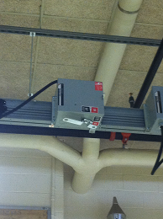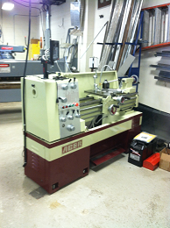

|  |  |  |
| --- | --- | --- |
| Nardini Dynamic 1400 G Engine Lathe #6 | | |
| *Step #* | *Energy Type* | **Shutdown Procedure** |
| 1 | any/all | Notify all affected employees of planned shutdown |
| 2 | any/all | Shutdown equipment at main switch |
| 3 | electrical | Turn off Bus A breaker in Panel B |
| 4 | electrical | Apply NMCC approved LOTO to breaker |
| 5 | electrical | Disconnect cord/plug on Digital Readout |
| 6 | electrical | Apply canister to Digital Readout cord/plug |
| 7 | electrical | Apply NMCC approved LOTO to canister |
| 8 | any/all | Place operator switch in either the I or II position. Check to make sure the  emergency stop button is not depressed. |
| 9 | any/all | Place the chuck guard into the operating position and remove the FWD/RVS lever to verify that all energy sources have been removed. |
| 10 | any/all | Perform required service according to manufacturer’s specs when  available |

|  |  |  |
| --- | --- | --- |
| Nardini Dynamic 1400 G Engine Lathe #6 | | |
| *Step #* | *Energy Type* | **Startup Procedure** |
| 1 | any/all | Check for complete reassembly |
| 2 | any/all | Check equipment to insure complete removal of tools, repair materials, etc. |
| 3 | any/all | Replace all covers/guards |
| 4 | electrical | Remove LOTO from all canisters |
| 5 | electrical | Remove canister from Digital Readout cord/plug |
| 6 | electrical | Reconnect Digital Readout cord/plug |
| 7 | electrical | Remove LOTO from Bus B breaker in Panel B |
| 8 | electrical | Turn on equipment at main switch to verify proper operation |
| 9 | any/all | Notify affected employees that the servicing or maintenance is complete and the machine or equipment is ready for use |

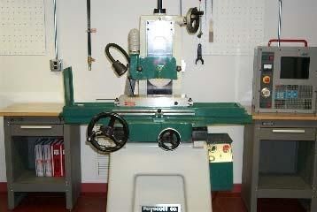

|  |  |  |
| --- | --- | --- |
| Surface Grinder #1 | | |
| *Step #* | *Energy Type* | **Shutdown Procedure** |
| 1 | any/all | Notify all affected employees of planned shutdown |
| 2 | any/all | Shut down equipment at operator’s controls |
| 3 | electrical | Move breaker #37,39,41 to the “off” position |
| 4 | electrical | Apply NMCC approved LOTO to breaker #37, 39, 41 |
| 5 | electrical | Activate start button to verify removal of power |
| 6 | any/all | Perform required service according to manufacturer’s specs when available |

|  |  |  |
| --- | --- | --- |
| Surface Grinder #1 | | |
| *Step #* | *Energy Type* | **Startup Procedure** |
| 1 | any/all | Check for complete reassembly |
| 2 | any/all | Check equipment to insure complete removal of tools, repair materials, etc. |
| 3 | any/all | Replace all covers/guards |
| 4 | electrical | Remove LOTO from breaker #37, 39, 41 |
| 5 | electrical | Move breaker #37, 39, 41 to the “on” position |
| 6 | electrical | Activate system to verify proper operation |
| 7 | any/all | Notify affected employees that the servicing or maintenance is complete and  the machine or equipment is ready for use. |



|  |  |  |
| --- | --- | --- |
| Surface Grinder #2 | | |
| *Step #* | *Energy Type* | **Shutdown Procedure** |
| 1 | any/all | Notify all affected employees of planned shutdown |
| 2 | any/all | Shut down equipment at operator’s controls |
| 3 | electrical | Move breaker #38,40,42 to the “off” position |
| 4 | electrical | Apply NMCC approved LOTO to breaker #38, 40, 42 |
| 5 | electrical | Activate start button to verify removal of power |
| 6 | any/all | Perform required service according to manufacturer’s specs when available |

|  |  |  |
| --- | --- | --- |
| Surface Grinder #2 | | |
| *Step #* | *Energy Type* | **Startup Procedure** |
| 1 | any/all | Check for complete reassembly |
| 2 | any/all | Check equipment to insure complete removal of tools, repair materials, etc. |
| 3 | any/all | Replace all covers/guards |
| 4 | electrical | Remove LOTO from breaker #38, 40, 42 |
| 5 | electrical | Move breaker #38, 40, 42 to the “on” position |
| 6 | electrical | Activate system to verify proper operation |
| 7 | any/all | Notify affected employees that the servicing or maintenance is complete and  the machine or equipment is ready for use. |

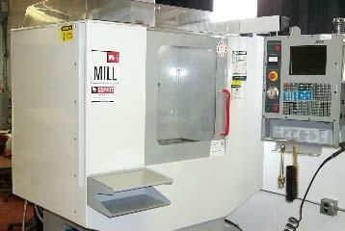

|  |  |  |
| --- | --- | --- |
| Precision Metals Mill #1 | | |
| *Step #* | *Energy Type* | **Shutdown Procedure** |
| 1 | any/all | Notify all affected employees of planned shutdown |
| 2 | any/all | Shut down equipment at operator’s controls |
| 3 | air | Shut off air supply valve |
| 4 | air | Disconnect air hose to bleed air from system |
| 5 | air | Apply NMCC approved LOTO to valve |
| 6 | electrical | Move Breaker #26,28,30 to the “off” position |
| 7 | electrical | Apply NMCC approved LOTO to breaker #26, 28, 30 |
| 8 | air/electrical | Activate start button to verify removal of all energy sources |
| 9 | any/all | Perform required service according to manufacturer’s specs when  available |

|  |  |  |
| --- | --- | --- |
| Precision Metals Mill #1 | | |
| *Step #* | *Energy Type* | **Startup Procedure** |
| 1 | any/all | Check for complete reassembly |
| 2 | any/all | Check equipment to insure complete removal of tools, repair materials, etc. |
| 3 | any/all | Replace all covers/guards |
| 4 | electrical | Remove LOTO from breaker #26, 28, 29 |
| 5 | electrical | Move breaker #26, 28, 30 to the “on” position |
| 6 | air | Remove LOTO from air supply valve |
| 7 | air | Reconnect air hose |
| 8 | air | Open air supply valve |
| 9 | air/electrical | Activate start button to verify proper operation |
| 10 | any/all | Notify affected employees that the servicing or maintenance is complete and the machine or equipment is ready for use |



|  |  |  |
| --- | --- | --- |
| Precision Metals Mill #2 | | |
| *Step #* | *Energy Type* | **Shutdown Procedure** |
| 1 | any/all | Notify all affected employees of planned shutdown |
| 2 | any/all | Shut down equipment at operator’s controls |
| 3 | air | Shut off air supply valve |
| 4 | air | Disconnect air hose to bleed air from system |
| 5 | air | Apply NMCC approved LOTO to valve |
| 6 | electrical | Move Breaker #25, 27, 29 to the “off” position |
| 7 | electrical | Apply NMCC approved LOTO to breaker #25, 27, 29 |
| 8 | air/electrical | Activate start button to verify removal of all energy sources |
| 9 | any/all | Perform required service according to manufacturer’s specs when  available |

|  |  |  |
| --- | --- | --- |
| Precision Metals Mill #2 | | |
| *Step #* | *Energy Type* | **Startup Procedure** |
| 1 | any/all | Check for complete reassembly |
| 2 | any/all | Check equipment to insure complete removal of tools, repair materials, etc. |
| 3 | any/all | Replace all covers/guards |
| 4 | electrical | Remove LOTO from breaker #25, 27, 29 |
| 5 | electrical | Move breaker #25, 27, 29 to the “on” position |
| 6 | air | Remove LOTO from air supply valve |
| 7 | air | Reconnect air hose |
| 8 | air | Open air supply valve |
| 9 | air/electrical | Activate start button to verify proper operation |
| 10 | any/all | Notify affected employees that the servicing or maintenance is complete and the machine or equipment is ready for use |

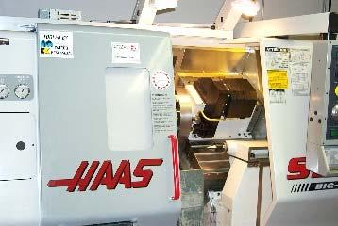

|  |  |  |
| --- | --- | --- |
| Precision Metals Lathe #1 | | |
| *Step #* | *Energy Type* | **Shutdown Procedure** |
| 1 | any/all | Notify all affected employees of planned shutdown |
| 2 | any/all | Shut down equipment at operator’s controls |
| 3 | air | Shut off air supply valve |
| 4 | air | Disconnect air hose to bleed air pressure |
| 5 | air | Apply NMCC approved LOTO to valve |
| 6 | electrical | Move Breaker #20,22,24 to the “off” position |
| 7 | electrical | Apply NMCC approved LOTO to breaker #20, 22, 24 |
| 8 | air/electrical | Activate start button to verify removal of all energy sources |
| 9 | any/all | Perform required service according to manufacturer’s specs when  available |

|  |  |  |
| --- | --- | --- |
| Precision Metals Lathe #1 | | |
| *Step #* | *Energy Type* | **Startup Procedure** |
| 1 | any/all | Check for complete reassembly |
| 2 | any/all | Check equipment to insure complete removal of tools, repair materials, etc. |
| 3 | any/all | Replace all covers/guards |
| 4 | electrical | Remove LOTO from breaker #20, 22, 24 |
| 5 | electrical | Move breaker #20,22,24 to the “on” position |
| 6 | air | Remove LOTO from air supply valve |
| 7 | air | Reconnect air hose |
| 8 | air | Open air supply valve |
| 9 | air/electrical | Activate start button to verify proper operation |
| 10 | any/all | Notify affected employees that the servicing or maintenance is complete and the machine or equipment is ready for use |



|  |  |  |
| --- | --- | --- |
| Precision Metals Lathe #2 | | |
| *Step #* | *Energy Type* | **Shutdown Procedure** |
| 1 | any/all | Notify all affected employees of planned shutdown |
| 2 | any/all | Shut down equipment at operator’s controls |
| 3 | air | Shut off air supply valve |
| 4 | air | Disconnect air hose to bleed air pressure |
| 5 | air | Apply NMCC approved LOTO to valve |
| 6 | electrical | Move Breaker #1,3,5 to the “off” position |
| 7 | electrical | Apply NMCC approved LOTO to breaker #1,3,5 |
| 8 | air/electrical | Activate start button to verify removal of all energy sources |
| 9 | any/all | Perform required service according to manufacturer’s specs when  available |

|  |  |  |
| --- | --- | --- |
| Precision Metals Lathe #2 | | |
| *Step #* | *Energy Type* | **Startup Procedure** |
| 1 | any/all | Check for complete reassembly |
| 2 | any/all | Check equipment to insure complete removal of tools, repair materials, etc. |
| 3 | any/all | Replace all covers/guards |
| 4 | electrical | Remove LOTO from breaker #1,3,5 |
| 5 | electrical | Move breaker #1,3,5 to the “on” position |
| 6 | air | Remove LOTO from air supply valve |
| 7 | air | Reconnect air hose |
| 8 | air | Open air supply valve |
| 9 | air/electrical | Activate start button to verify proper operation |
| 10 | any/all | Notify affected employees that the servicing or maintenance is complete and the machine or equipment is ready for use |

***Hydraulic pressure may still be present on chuck locks***

|  |  |  |
| --- | --- | --- |
| ***Precision Machining Shop Exempt Equipment*** This includes all mobile and/or connected, single energy source devices | | |
| *Step #* | *Energy Type* | **Shutdown Procedure** |
| 1 | any/all | Remove plug from receptacle. |
| 2 | any/all | If service person does not have complete control of plug or has to leave device for any length of time place protective canister over plug. |
| 3 | any/all | Apply NMCC approved LOTO |
| 4 | any/all | Reverse procedure to verify proper operation. |

# STRUCTURAL WELDING

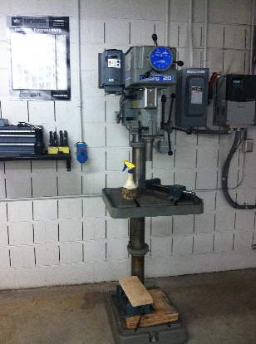\

|  |  |  |
| --- | --- | --- |
| Clausing Drill Press | | |
| *Step #* | *Energy Type* | **Shutdown Procedure** |
| 1 | any/all | Notify all affected employees of planned shutdown |
| 2 | any/all | Shutdown equipment operator controls |
| 3 | electrical | Move breaker to the “off” position |
| 4 | electrical | Apply NMCC approved LOTO to breaker |
| 5 | electrical | Activate operator controls to verify all energy sources are removed |
| 6 | any/all | Perform required service according to manufacturer’s specs when available |

|  |  |  |
| --- | --- | --- |
| Clausing Drill Press | | |
| *Step #* | *Energy Type* | **Startup Procedure** |
| 1 | any/all | Check for complete reassembly |
| 2 | any/all | Check equipment to insure complete removal of tools, repair materials, etc. |
| 3 | any/all | Replace all covers/guards |
| 4 | electrical | Remove LOTO from breaker |
| 5 | electrical | Move disconnect to “on” position |
| 6 | electrical | Move breaker to “on” position |
| 7 | electrical | Activate start button to verify proper operation |
| 8 | any/all | Notify affected employees that the servicing or maintenance is complete  and the machine or equipment is ready for use |

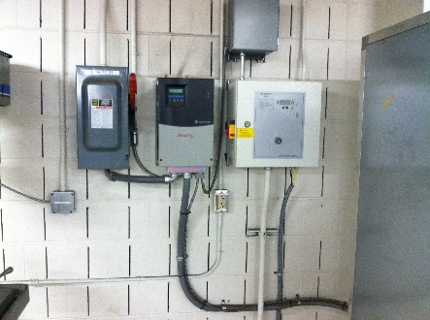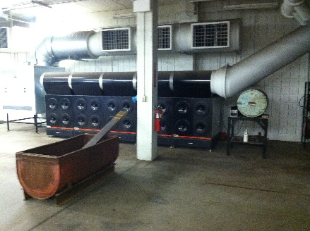

|  |  |  |
| --- | --- | --- |
| Lincoln Air Filter | | |
| *Step #* | *Energy Type* | **Shutdown Procedure** |
| 1 | any/all | Notify all affected employees of planned shutdown |
| 2 | any/all | Shutdown equipment operator controls- Switch PIW RS 31 |
| 3 | electrical | Apply NMCC approved LOTO to breaker |
| 4 | electrical | Activate operator controls to verify all energy sources are removed |
| 5 | any/all | Perform required service according to manufacturer’s specs when available |

|  |  |  |
| --- | --- | --- |
| Lincoln Air Filter | | |
| *Step #* | *Energy Type* | **Startup Procedure** |
| 1 | any/all | Check for complete reassembly |
| 2 | any/all | Check equipment to insure complete removal of tools, repair materials, etc. |
| 3 | any/all | Replace all covers/guards |
| 4 | electrical | Remove LOTO from breaker |
| 5 | electrical | Move breaker to “on” position |
| 6 | electrical | Activate start button to verify proper operation |
| 7 | any/all | Notify affected employees that the servicing or maintenance is complete  and the machine or equipment is ready for use |

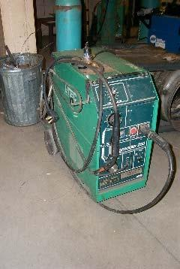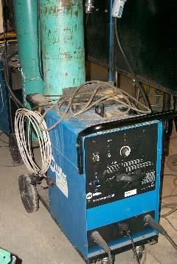

|  |  |  |
| --- | --- | --- |
| Welder (Capacitor Energy) | | |
| *Step #* | *Energy Type* | **Shutdown Procedure** |
| 1 | any/all | Remove plug from receptacle |
| 2 | any/all | Place protective canister over plug |
| 3 | electrical | Apply NMCC approved LOTO to canister |
| 4 | electrical | Discharge capacitor where applicable according to manufacturer’s  specifications |
| 5 | electrical | Perform required service according to manufacturer’s specs when available |

|  |  |  |
| --- | --- | --- |
| Welder (Capacitor Energy) | | |
| *Step #* | *Energy Type* | **Startup Procedure** |
| 1 | any/all | Check for complete reassembly |
| 2 | any/all | Check equipment to insure complete removal of tools, repair materials, etc. |
| 3 | any/all | Replace all covers/guards |
| 4 | electrical | Remove LOTO from canister |
| 5 | any/all | Remove canister from plug |
| 6 | any/all | Place plug in receptacle |
| 7 | any/all | Notify affected employees that the servicing or maintenance is complete  and the machine or equipment is ready for use |

|  |  |  |
| --- | --- | --- |
| ***Welding Shop Exempt Equipment*** This includes all mobile and/or connected, single energy source devices | | |
| *Step #* | *Energy Type* | **Shutdown Procedure** |
| 1 | any/all | Remove plug from receptacle. |
| 2 | any/all | If service person does not have complete control of plug or has to leave device for any length of time place protective canister over plug. |
| 3 | any/all | Apply NMCC approved LOTO |
| 4 | any/all | Reverse procedure to verify proper operation. |

# WIND POWER TECHNOLOGY

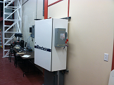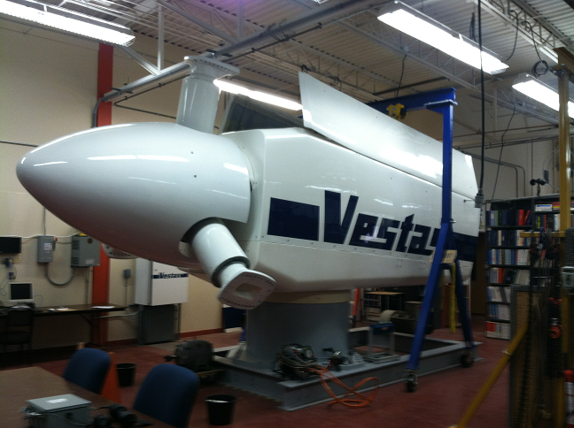

|  |  |  |
| --- | --- | --- |
| Vespas Wind Turbine | | |
| *Step #* | *Energy Type* | **Shutdown Procedure** |
| 1 | any/all | Notify all affected employees of planned shutdown |
| 2 | electrical | Move Switch on side of Vespas control unit to off position |
| 3 | electrical | Apply NMCC approved LOTO to Switch on side of Vespas control unit |
| 4 | electrical | Activate operator controls to verify all energy sources are removed |
| 5 | any/all | Perform required service according to manufacturer’s specs when  available |

|  |  |  |
| --- | --- | --- |
| Vespas Wind Turbine | | |
| *Step #* | *Energy Type* | **Startup Procedure** |
| 1 | any/all | Check for complete reassembly |
| 2 | any/all | Check equipment to insure complete removal of tools, repair materials, etc. |
| 3 | any/all | Replace all covers/guards |
| 4 | electrical | Remove LOTO from control unit |
| 5 | electrical | Move breaker to “on” position |
| 6 | electrical | Activate start button to verify proper operation |
| 7 | any/all | Notify affected employees that the servicing or maintenance is complete  and the machine or equipment is ready for use |

# 

# MAINTENANCE & PHYSICAL PLANT PROCEDURES

\

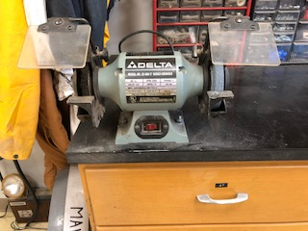

|  |  |  |
| --- | --- | --- |
| 6” GrinderLocation: Building 226 Maintenance ShopVoltages: 120v | | |
| *Step #* | *Energy Type* | **Shutdown Procedure** |
| 1 | any/all | Notify all affected employees of planned shutdown |
| 2 | any/all | Remove plug from receptacle. |
| 3 | electrical | If service person does not have complete control of plug or has to leave device for any length of time place protective canister over plug. |
| 4 | electrical | Apply NMCC approved LOTO to canister |
| 5 | electrical | Activate start button to verify removal of power |
| 6 | any/all | Perform required service according to manufacturer’s specs when  available |

|  |  |  |
| --- | --- | --- |
| 6” GrinderLocation: Building 226 Maintenance ShopVoltages: 120v | | |
| *Step #* | *Energy Type* | **Startup Procedure** |
| 1 | any/all | Check for complete reassembly |
| 2 | any/all | Check equipment to insure complete removal of tools, repair materials, etc. |
| 3 | any/all | Replace all covers/guards |
| 4 | electrical | Remove LOTO from canister |
| 5 | electrical | Plug in equipment |
| 6 | electrical | Activate start button to verify proper operation |
| 7 | any/all | Notify affected employees that the servicing or maintenance is complete and the machine or equipment is ready for use |

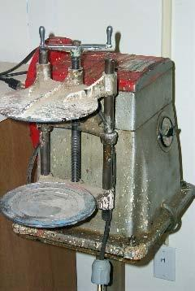

|  |  |  |
| --- | --- | --- |
| Red Devil Paint ConditionerLocation: Building 226 Maintenance ShopVoltages: 120v | | |
| *Step #* | *Energy Type* | **Shutdown Procedure** |
| 1 | any/all | Notify all affected employees of planned shutdown |
| 2 | any/all | Remove plug from receptacle. |
| 3 | electrical | If service person does not have complete control of plug or has to leave device for any length of time place protective canister over plug. |
| 4 | electrical | Apply NMCC approved LOTO to canister |
| 5 | electrical | Activate start button to verify removal of power |
| 6 | any/all | Perform required service according to manufacturer’s specs when  available |

|  |  |  |
| --- | --- | --- |
| Red Devil Paint ConditionerLocation: Building 226 Maintenance ShopVoltages: 120v | | |
| *Step #* | *Energy Type* | **Startup Procedure** |
| 1 | any/all | Check for complete reassembly |
| 2 | any/all | Check equipment to insure complete removal of tools, repair materials, etc. |
| 3 | any/all | Replace all covers/guards |
| 4 | electrical | Remove LOTO from canister |
| 5 | electrical | Plug in equipment |
| 6 | electrical | Activate start button to verify proper operation |
| 7 | any/all | Notify affected employees that the servicing or maintenance is complete and the machine or equipment is ready for use |

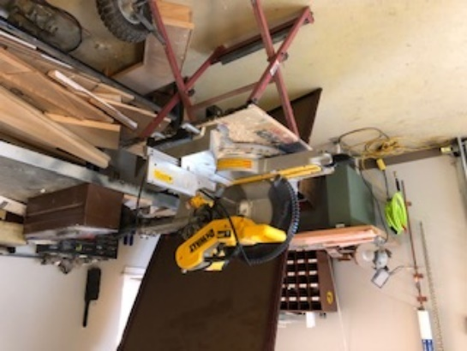

|  |  |  |
| --- | --- | --- |
| 12” Compound Miter SawLocation: Building 226 Maintenance ShopVoltages: 120v | | |
| *Step #* | *Energy Type* | **Shutdown Procedure** |
| 1 | any/all | Notify all affected employees of planned shutdown |
| 2 | any/all | Remove plug from receptacle. |
| 3 | electrical | If service person does not have complete control of plug or has to leave device for any length of time place protective canister over plug. |
| 4 | electrical | Apply NMCC approved LOTO to canister |
| 5 | electrical | Activate start button to verify removal of power |
| 6 | any/all | Perform required service according to manufacturer’s specs when  available |

|  |  |  |
| --- | --- | --- |
| 12” Compound Miter SawLocation: Building 226 Maintenance ShopVoltages: 120v | | |
| *Step #* | *Energy Type* | **Startup Procedure** |
| 1 | any/all | Check for complete reassembly |
| 2 | any/all | Check equipment to insure complete removal of tools, repair materials, etc. |
| 3 | any/all | Replace all covers/guards |
| 4 | electrical | Remove LOTO from canister |
| 5 | electrical | Plug in equipment |
| 6 | electrical | Activate start button to verify proper operation |
| 7 | any/all | Notify affected employees that the servicing or maintenance is complete and the machine or equipment is ready for use |

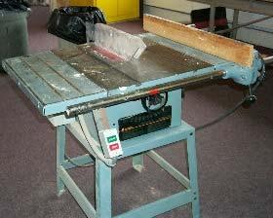

|  |  |  |
| --- | --- | --- |
| Contractors Table SawLocation: Building 226 Maintenance ShopVoltages: 120v | | |
| *Step #* | *Energy Type* | **Shutdown Procedure** |
| 1 | any/all | Notify all affected employees of planned shutdown |
| 2 | any/all | Remove plug from receptacle. |
| 3 | electrical | If service person does not have complete control of plug or has to leave device for any length of time place protective canister over plug. |
| 4 | electrical | Apply NMCC approved LOTO to canister |
| 5 | electrical | Activate start button to verify removal of power |
| 6 | any/all | Perform required service according to manufacturer’s specs when  available |

|  |  |  |
| --- | --- | --- |
| Contractors Table SawLocation: Building 226 Maintenance ShopVoltages: 120v | | |
| *Step #* | *Energy Type* | **Startup Procedure** |
| 1 | any/all | Check for complete reassembly |
| 2 | any/all | Check equipment to insure complete removal of tools, repair materials, etc. |
| 3 | any/all | Replace all covers/guards |
| 4 | electrical | Remove LOTO from canister |
| 5 | electrical | Plug in equipment |
| 6 | electrical | Activate start button to verify proper operation |
| 7 | any/all | Notify affected employees that the servicing or maintenance is complete and the machine or equipment is ready for use |

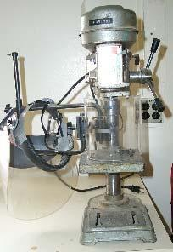

|  |  |  |
| --- | --- | --- |
| Drill PressLocation: Building 226 Maintenance ShopVoltages: 120v | | |
| *Step #* | *Energy Type* | **Shutdown Procedure** |
| 1 | any/all | Notify all affected employees of planned shutdown |
| 2 | any/all | Remove plug from receptacle. |
| 3 | electrical | If service person does not have complete control of plug or has to leave device for any length of time place protective canister over plug. |
| 4 | electrical | Apply NMCC approved LOTO to canister |
| 5 | electrical | Activate start button to verify removal of power |
| 6 | any/all | Perform required service according to manufacturer’s specs when  available |

|  |  |  |
| --- | --- | --- |
| Drill PressLocation: Building 226 Maintenance ShopVoltages: 120v | | |
| *Step #* | *Energy Type* | **Startup Procedure** |
| 1 | any/all | Check for complete reassembly |
| 2 | any/all | Check equipment to insure complete removal of tools, repair materials, etc. |
| 3 | any/all | Replace all covers/guards |
| 4 | electrical | Remove LOTO from canister |
| 5 | electrical | Plug in equipment |
| 6 | electrical | Activate start button to verify proper operation |
| 7 | any/all | Notify affected employees that the servicing or maintenance is complete and the machine or equipment is ready for use |

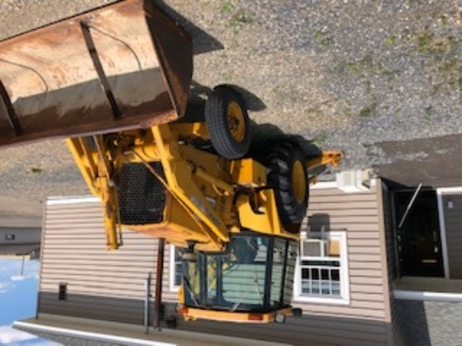

|  |  |  |
| --- | --- | --- |
| Mobile Equipment – Backhoe LoaderLocation: Maintenance Area | | |
| *Step #* | *Energy Type* | **Shutdown Procedure** |
| 1 | electrical | Battery terminals will be disconnected, locked, tagged, and equipment  verified it will not start. |
| 2 | any/all | Ignition keys removed and hung on key board in shop office. |
| 3 | any/all | Wheels chalked with parking brake set to prevent unwanted vehicle  movement. |
| 4 | any/all | All hydraulic systems / cylinders will have pressure bled off with cylinders  retracted or block with designated safety stands if service is required.  Verify all hydraulic functions will not move. |
| 5 | any/all | All articulating functions shall be isolated with bars to prevent unintentional movement. |

|  |  |  |
| --- | --- | --- |
| Mobile Equipment – Backhoe LoaderLocation: Maintenance Area | | |
| *Step #* | *Energy Type* | **Startup Procedure** |
| 1 | any/all | Verify all serviced components are completely assembled and ready for operation |
| 2 | any/all | Insure all tools and other materials have been removed from area. |
| 3 | any/all | Replace all covers or guards removed for service. |
| 4 | electrical | Remove locks from equipment |
| 5 | electrical | Reconnect battery terminals |
| 6 | electrical | Activate start button to verify proper operation |
| 7 | any/all | Have certified operator check functions of equipment while service tech inspects for hydraulic leaks. |

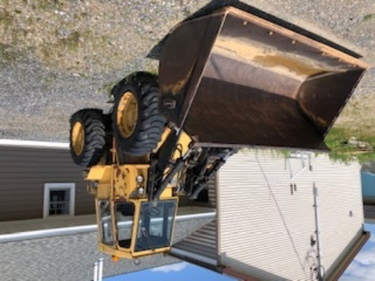

|  |  |  |
| --- | --- | --- |
| Mobile Equipment – Fronted LoaderLocation: Maintenance Area | | |
| *Step #* | *Energy Type* | **Shutdown Procedure** |
| 1 | electrical | Battery terminals will be disconnected, locked, tagged, and equipment  verified it will not start. |
| 2 | any/all | Ignition keys removed and hung on key board in shop office. |
| 3 | any/all | Wheels chalked with parking brake set to prevent unwanted vehicle  movement. |
| 4 | any/all | All hydraulic systems / cylinders will have pressure bled off with cylinders  retracted or block with designated safety stands if service is required.  Verify all hydraulic functions will not move. |
| 5 | any/all | All articulating functions shall be isolated with bars to prevent unintentional movement. |

|  |  |  |
| --- | --- | --- |
| Mobile Equipment – Fronted LoaderLocation: Maintenance Area | | |
| *Step #* | *Energy Type* | **Startup Procedure** |
| 1 | any/all | Verify all serviced components are completely assembled and ready for operation |
| 2 | any/all | Insure all tools and other materials have been removed from area. |
| 3 | any/all | Replace all covers or guards removed for service. |
| 4 | any/all | Remove locks from equipment |
| 5 | electrical | Reconnect battery terminals |
| 6 | electrical | Have certified operator check functions of equipment while service tech inspects for hydraulic leaks. |

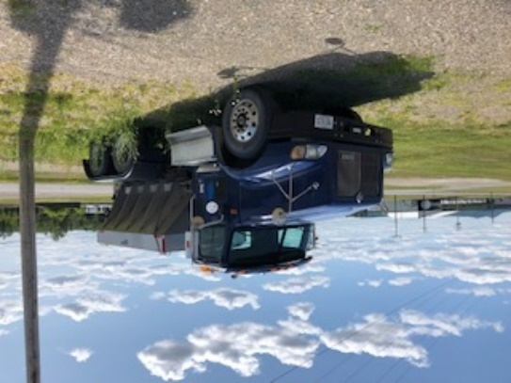

|  |  |  |
| --- | --- | --- |
| Mobile Equipment – Sanding TruckLocation: Maintenance Area | | |
| *Step #* | *Energy Type* | **Shutdown Procedure** |
| 1 | electrical | Battery terminals will be disconnected, locked, tagged, and equipment  verified it will not start. |
| 2 | any/all | Ignition keys removed and hung on key board in shop office. |
| 3 | any/all | Wheels chalked with parking brake set to prevent unwanted vehicle  movement. |
| 4 | any/all | Isolated and bleed off hydraulic pressure if service is being conducted on sanding motor. |

|  |  |  |
| --- | --- | --- |
| Mobile Equipment – Sanding TruckLocation: Maintenance Area | | |
| *Step #* | *Energy Type* | **Startup Procedure** |
| 1 | any/all | Verify all serviced components are completely assembled and ready for operation |
| 2 | any/all | Insure all tools and other materials have been removed from area. |
| 3 | any/all | Replace all covers or guards removed for service. |
| 4 | any/all | Remove locks from equipment |
| 5 | electrical | Reconnect battery terminals |
| 6 | electrical | Have certified operator check functions of serviced components. |

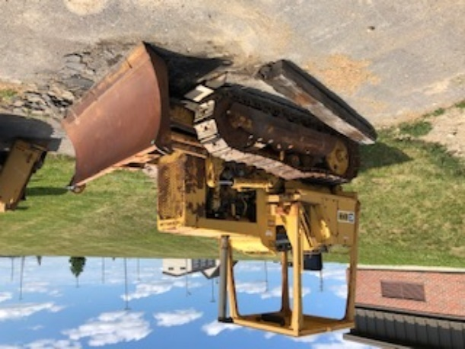

|  |  |  |
| --- | --- | --- |
| Mobile Equipment – Bull DozerLocation: Maintenance Area | | |
| *Step #* | *Energy Type* | **Shutdown Procedure** |
| 1 | electrical | Battery terminals will be disconnected, locked, tagged, and equipment  verified it will not start. |
| 2 | any/all | Ignition keys removed and hung on key board in shop office. |
| 3 | potential | Tracks chalked to prevent unwanted vehicle moment |
| 4 | hydraulic | All hydraulic system pressure bled off and blade lowered to ground or blocked with designated safety stands if service is required. Verify all hydraulic functions will not move. |

|  |  |  |
| --- | --- | --- |
| Mobile Equipment – Bull DozerLocation: Maintenance Area | | |
| *Step #* | *Energy Type* | **Startup Procedure** |
| 1 | any/all | Verify all serviced components are completely assembled and ready for operation |
| 2 | any/all | Insure all tools and other materials have been removed from area. |
| 3 | any/all | Replace all covers or guards removed for service. |
| 4 | any/all | Remove locks from equipment |
| 5 | electrical | Reconnect battery terminals |
| 6 | electrical | Have certified operator check functions of serviced components. |

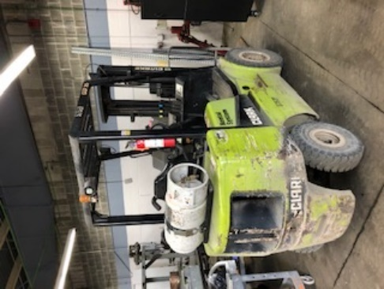

|  |  |  |
| --- | --- | --- |
| Mobile Equipment – Fork LiftLocation: Maintenance Area | | |
| *Step #* | *Energy Type* | **Shutdown Procedure** |
| 1 | electrical | Battery terminals will be disconnected, locked, tagged, and equipment  verified it will not start. |
| 2 | any/all | Ignition keys removed and hung on key board in shop office. |
| 3 | potential | Wheels chalked with parking brake set to prevent unwanted vehicle   moment |
| 4 | hydraulic | All hydraulic systems / cylinder’s pressure bled off and forks lowered to ground or blocked with designated safety stands if service is required. Verify all hydraulic functions will not move. |
| 5 | any/all | Propane gas cylinder turned off and disconnected from tank. |

|  |  |  |
| --- | --- | --- |
| Mobile Equipment – Fork LiftLocation: Maintenance Area | | |
| *Step #* | *Energy Type* | **Startup Procedure** |
| 1 | any/all | Verify all serviced components are completely assembled and ready for operation |
| 2 | any/all | Insure all tools and other materials have been removed from area. |
| 3 | any/all | Replace all covers or guards removed for service. |
| 4 | any/all | Remove locks from equipment and reconnect propane tank |
| 5 | electrical | Reconnect battery terminals |
| 6 | electrical | Have certified operator check functions of serviced components. |

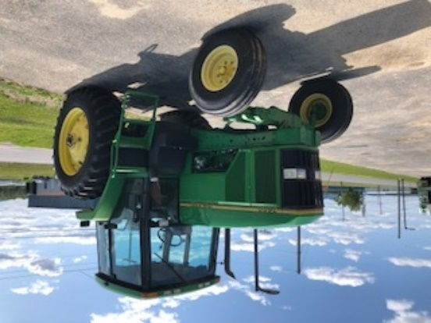

|  |  |  |
| --- | --- | --- |
| Mobile Equipment – John Deere TractorLocation: Maintenance Area | | |
| *Step #* | *Energy Type* | **Shutdown Procedure** |
| 1 | electrical | Battery terminals will be disconnected, locked, tagged, and equipment  verified it will not start. |
| 2 | any/all | Ignition keys removed and hung on key board in shop office. |
| 3 | potential | Wheels chalked with parking brake set to prevent unwanted vehicle   moment |
| 4 | hydraulic | All hydraulic system / cylinder pressure bled off and 3-point hitch lowered to ground or blocked with designated safety stands if service is required. Verify all hydraulic functions will not move. |

|  |  |  |
| --- | --- | --- |
| Mobile Equipment – John Deere TractorLocation: Maintenance Area | | |
| *Step #* | *Energy Type* | **Startup Procedure** |
| 1 | any/all | Verify all serviced components are completely assembled and ready for operation |
| 2 | any/all | Insure all tools and other materials have been removed from area. |
| 3 | any/all | Replace all covers or guards removed for service. |
| 4 | any/all | Remove locks from equipment |
| 5 | electrical | Reconnect battery terminals |
| 6 | electrical | Have certified operator check functions of serviced components. |

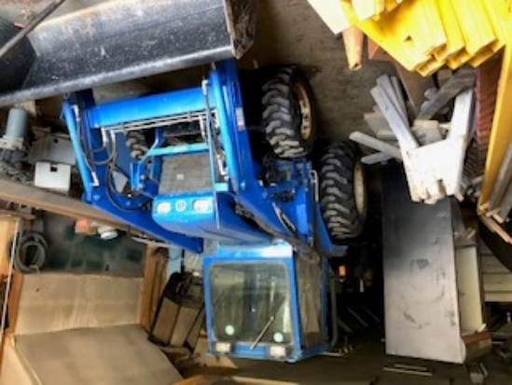

|  |  |  |
| --- | --- | --- |
| Mobile Equipment – New Holland TractorLocation: Maintenance Area | | |
| *Step #* | *Energy Type* | **Shutdown Procedure** |
| 1 | electrical | Battery terminals will be disconnected, locked, tagged, and equipment  verified it will not start. |
| 2 | any/all | Ignition keys removed and hung on key board in shop office. |
| 3 | potential | Wheels chalked with parking brake set to prevent unwanted vehicle   moment |
| 4 | hydraulic | All hydraulic system / cylinder pressure bled off and 3-point hitch lowered to ground or blocked with designated safety stands if service is required. Verify all hydraulic functions will not move. |

|  |  |  |
| --- | --- | --- |
| Mobile Equipment – New Holland TractorLocation: Maintenance Area | | |
| *Step #* | *Energy Type* | **Startup Procedure** |
| 1 | any/all | Verify all serviced components are completely assembled and ready for operation |
| 2 | any/all | Insure all tools and other materials have been removed from area. |
| 3 | any/all | Replace all covers or guards removed for service. |
| 4 | any/all | Remove locks from equipment |
| 5 | electrical | Reconnect battery terminals |
| 6 | electrical | Have certified operator check functions of serviced components. |

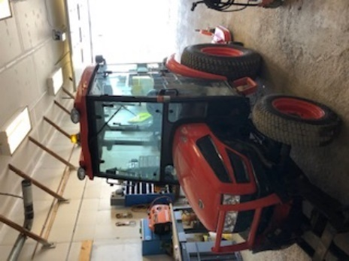

|  |  |  |
| --- | --- | --- |
| Mobile Equipment – Kioti CK27 TractorLocation: Maintenance Area | | |
| *Step #* | *Energy Type* | **Shutdown Procedure** |
| 1 | electrical | Battery terminals will be disconnected, locked, tagged, and equipment  verified it will not start. |
| 2 | any/all | Ignition keys removed and hung on key board in shop office. |
| 3 | potential | Wheels chalked with parking brake set to prevent unwanted vehicle   moment |
| 4 | hydraulic | All hydraulic system / cylinder pressure bled off and 3-point hitch lowered to ground or blocked with designated safety stands if service is required. Verify all hydraulic functions will not move. |

|  |  |  |
| --- | --- | --- |
| Mobile Equipment – Kioti CK27 TractorLocation: Maintenance Area | | |
| *Step #* | *Energy Type* | **Startup Procedure** |
| 1 | any/all | Verify all serviced components are completely assembled and ready for operation |
| 2 | any/all | Insure all tools and other materials have been removed from area. |
| 3 | any/all | Replace all covers or guards removed for service. |
| 4 | any/all | Remove locks from equipment |
| 5 | electrical | Reconnect battery terminals |
| 6 | electrical | Have certified operator check functions of serviced components. |

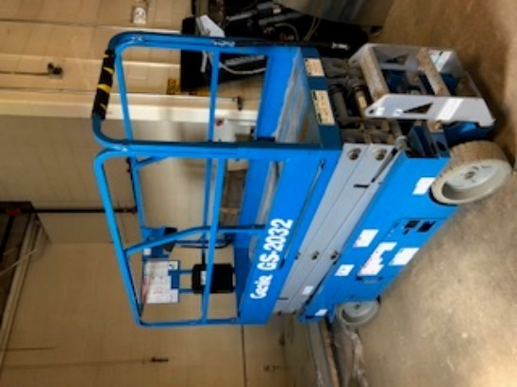

|  |  |  |
| --- | --- | --- |
| Mobile Equipment – Scissor LiftLocation: Maintenance Area | | |
| *Step #* | *Energy Type* | **Shutdown Procedure** |
| 1 | electrical | Battery terminals will be disconnected, locked, tagged, and equipment  verified it will not start |
| 2 | any/all | Ignition keys removed and hung on key board in shop office. |
| 3 | potential | Wheels chalked with parking brake set to prevent unwanted vehicle   moment |
| 4 | hydraulic | All hydraulic system / cylinder pressure bled off and 3-point hitch lowered to ground or blocked with designated safety stands if service is required. Verify all hydraulic functions will not move. |

|  |  |  |
| --- | --- | --- |
| Mobile Equipment – Scissor LiftLocation: Maintenance Area | | |
| *Step #* | *Energy Type* | **Startup Procedure** |
| 1 | any/all | Verify all serviced components are completely assembled and ready for operation |
| 2 | any/all | Insure all tools and other materials have been removed from area. |
| 3 | any/all | Replace all covers or guards removed for service. |
| 4 | any/all | Remove locks from equipment |
| 5 | electrical | Reconnect battery terminals |
| 6 | electrical | Have certified operator check functions of serviced components. |

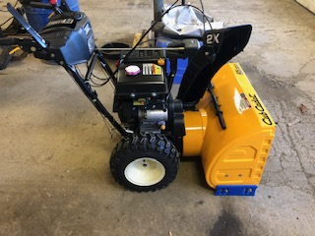

|  |  |  |
| --- | --- | --- |
| Mobile Equipment – Snow BlowerLocation: Maintenance Area | | |
| *Step #* | *Energy Type* | **Shutdown Procedure** |
| 1 | any/all | Ignition keys removed and hung on key board in shop office. |
| 2 | any/all | Key removed and locked in lock box in shop. |
| 3 | potential |  |

|  |  |  |
| --- | --- | --- |
| Mobile Equipment – Snow BlowerLocation: Maintenance Area | | |
| *Step #* | *Energy Type* | **Startup Procedure** |
| 1 | any/all | Verify all serviced components are completely assembled and ready for operation |
| 2 | any/all | Insure all tools and other materials have been removed from area. |
| 3 | any/all | Replace all covers or guards removed for service. |
| 4 | any/all | Remove locks from equipment |
| 5 | electrical | Have certified operator check functions of serviced components. |



|  |  |  |
| --- | --- | --- |
| Mobile Equipment – Passenger VehicleLocation: Maintenance Area | | |
| *Step #* | *Energy Type* | **Shutdown Procedure** |
| 1 | electric | Battery terminals will be disconnected, locked, tagged, and equipment  verified it will not start. |
| 2 | any/all | Ignition keys removed and hung on key board in shop office. |
| 3 | any/all | Wheels chalked parking brake set to prevent unwanted vehicle moment. |

|  |  |  |
| --- | --- | --- |
| Mobile Equipment – Passenger VehicleLocation: Maintenance Area | | |
| *Step #* | *Energy Type* | **Startup Procedure** |
| 1 | any/all | Verify all serviced components are completely assembled and ready for operation |
| 2 | any/all | Insure all tools and other materials have been removed from area. |
| 3 | any/all | Replace all covers or guards removed for service. |
| 4 | any/all | Remove locks from equipment |
| 5 | electrical | Reconnect battery terminals |
| 6 | electrical | Have certified operator check functions of equipment serviced. |

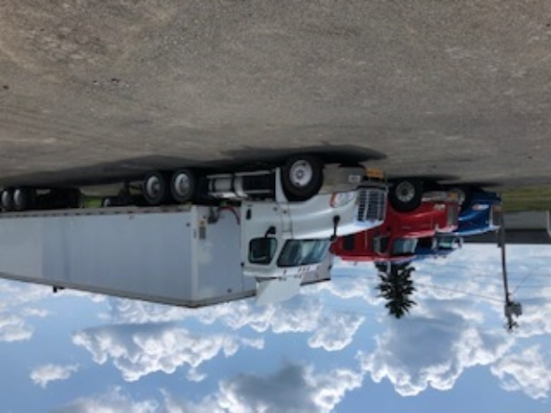

|  |  |  |
| --- | --- | --- |
| Mobile Equipment – Tractor TrailerLocation: Maintenance Area | | |
| *Step #* | *Energy Type* | **Shutdown Procedure** |
| 1 | electric | Battery terminals will be disconnected, locked, tagged, and equipment  verified it will not start. |
| 2 | any/all | Ignition keys removed and hung on key board in shop office. |
| 3 | any/all | Wheels chalked, brake air tank bled off with parking brake set to prevent  unwanted vehicle moment |

|  |  |  |
| --- | --- | --- |
| Mobile Equipment – Tractor TrailerLocation: Maintenance Area | | |
| *Step #* | *Energy Type* | **Startup Procedure** |
| 1 | any/all | Verify all serviced components are completely assembled and ready for operation |
| 2 | any/all | Insure all tools and other materials have been removed from area. |
| 3 | any/all | Replace all covers or guards removed for service. |
| 4 | any/all | Remove locks from equipment |
| 5 | electrical | Reconnect battery terminals |
| 6 | electrical | Have certified operator check functions of equipment serviced. |

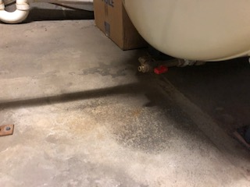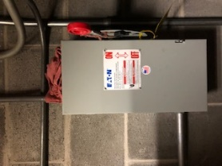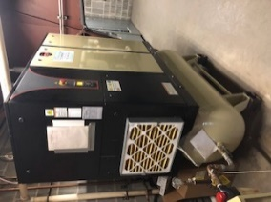

|  |  |  |
| --- | --- | --- |
| Air CompressorLocation: Bld. Maintenance Garage, Instrumentation and Controls Lab, Christie Building Labs, Sheet Metal Lab, Mailman TradesVoltages: 208v | | |
| *Step #* | *Energy Type* | **Shutdown Procedure** |
| 1 | any/all | Notify all affected employees of planned shutdown |
| 2 | air | Close tank valve to isolate compressor from air system |
| 3 | air | Apply NMCC approved LOTO to tank air valve |
| 4 | air | Open bleeder valve on bottom of tank or switch auto drain to manual  position to bleed tank |
| 5 | electrical | Apply NMCC approved LOTO to breaker or disconnect |
| 6 | both | Activate compressor and measure voltage at controls and motor to verify  removal of all energy sources |
| 7 | any/all | Perform required service according to manufacturer’s specs when  available |

|  |  |  |
| --- | --- | --- |
| Air CompressorLocation: Bld. Maintenance Garage, Instrumentation and Controls Lab, Christie Building Labs, Sheet Metal Lab, Mailman TradesVoltages: 208v | | |
| *Step #* | *Energy Type* | **Startup Procedure** |
| 1 | any/all | Check for complete reassembly |
| 2 | any/all | Check equipment to insure complete removal of tools, repair materials, etc |
| 3 | any/all | Replace all covers/guards |
| 4 | air | Close bleeder valve on tank |
| 5 | air | Open valve connecting tank to air system |
| 6 | electrical | Remove LOTO from breaker or disconnect |
| 7 | electric | Move breaker or disconnect to the “on” position |
| 8 | both | Activate start button to verify proper operation |
| 9 | any/all | Notify affected employees that the servicing or maintenance is complete  and the machine or equipment is ready for use |

***Caution should be used around air compressor pipes they may be hot.***

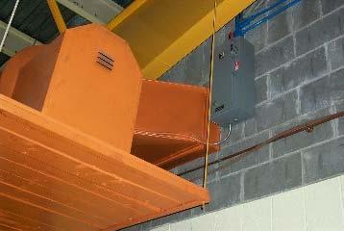

|  |  |  |
| --- | --- | --- |
| Exhaust Fan | | |
| *Step #* | *Energy Type* | **Shutdown Procedure** |
| 1 | any/all | Notify all affected employees of planned shutdown |
| 2 | any/all | Shut down equipment at operator’s controls |
| 3 | electrical | Move breaker to the “off” position |
| 4 | electrical | Apply NMCC approved LOTO to breaker |
| 5 | electrical | Activate operator control and measure voltage to verify all energy sources are removed |

|  |  |  |
| --- | --- | --- |
| Exhaust Fan | | |
| *Step #* | *Energy Type* | **Startup Procedure** |
| 1 | any/all | Check for complete reassembly |
| 2 | any/all | Check equipment to insure complete removal of tools, repair materials, etc. |
| 3 | any/all | Replace all covers/guards |
| 4 | electrical | Remove LOTO from breaker |
| 5 | electrical | Move breaker to the “on” position |
| 6 | both | Test operate lift to verify proper operation |
| 7 | any/all | Notify affected employees that the servicing or maintenance is complete  and the machine or equipment is ready for use |

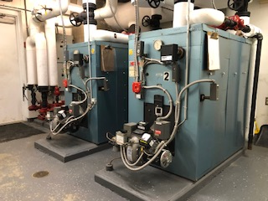

|  |  |  |
| --- | --- | --- |
| Campus Boilers | | |
| *Step #* | *Energy Type* | **Shutdown Procedure** |
| 1 | any/all | Notify all affected employees of planned shutdown |
| 2 | any/all | Shutdown equipment at service switch |
| 3 | electrical | Move circuit breaker or disconnect to the “off” position |
| 4 | electrical | Apply NMCC approved LOTO to breaker or disconnect |
| 5 | hot water | Close valves to isolate boiler from system |
| 6 | hot water | Apply NMCC approved LOTO to valves |
| 7 | hot water | Let equipment cool |
| 8 | hot water | Open drain at bottom of boiler to remove pressure and drain hot water |
| 9 | both | Activate service switch and measure voltages to verify all energy sources  are removed |
| 10 | any/all | Perform required service according to manufacturer’s specs when  available |

|  |  |  |
| --- | --- | --- |
| Campus Boilers | | |
| *Step #* | *Energy Type* | **Startup Procedure** |
| 1 | any/all | Check for complete reassembly |
| 2 | any/all | Check equipment to insure complete removal of tools, repair materials, etc. |
| 3 | any/all | Replace all covers/guards |
| 4 | hot water | Close drain valve |
| 5 | hot water | Refill furnace with water |
| 6 | electrical | Remove LOTO and device from isolating valve |
| 7 | electrical | Remove LOTO from breaker or disconnect |
| 8 | electrical | Move breaker to “on” position |
| 9 | any/all | Activate start button to verify proper operation |
| 10 | any/all | Notify affected employees that the servicing or maintenance is complete  and the machine or equipment is ready for use |

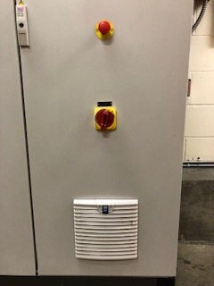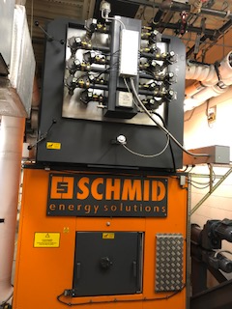

|  |  |  |
| --- | --- | --- |
| Campus Boilers | | |
| *Step #* | *Energy Type* | **Shutdown Procedure** |
| 1 | any/all | Notify all affected employees of planned shutdown |
| 2 | any/all | Shutdown equipment operator controls |
| 3 | electrical | Move main switch located on control cabinet to the “off” position |
| 4 | electrical | Apply NMCC approved LOTO to switch |
| 5 | electrical | Activate operator controls to verify all energy sources are removed |
| 6 | hot water | Close valves to isolate boiler from system |
| 7 | hot water | Apply NMCC approved LOTO to valves |
| 8 | hot water | Let equipment cool |
| 9 | hot water | Open drain at bottom of boiler to remove pressure and drain hot water |
| 10 | any/all | Perform required service according to manufacturer’s specs when  available |

|  |  |  |
| --- | --- | --- |
| Campus Boilers | | |
| *Step #* | *Energy Type* | **Startup Procedure** |
| 1 | any/all | Check for complete reassembly |
| 2 | any/all | Check equipment to insure complete removal of tools, repair materials, etc. |
| 3 | any/all | Replace all covers/guards |
| 4 | electrical | Remove LOTO from breaker |
| 5 | electrical | Move man switch to “on” position |
| 6 | electrical | Activate start button to verify proper operation |
| 7 | water | Remove LOTO from water valves, fill boiler, and bleed air from system. |
| 8 | any/all | Notify affected employees that the servicing or maintenance is complete  and the machine or equipment is ready for use |

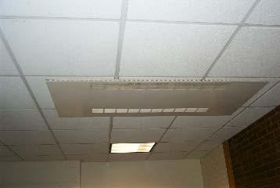

|  |  |  |
| --- | --- | --- |
| Ceiling Mounted HV UnitsLocation: Bld. 600 Christie Room 216, 215, 218, hallway by gym, hallway into Martin and Bookstore, Commons and Snow HallVoltages: 120/208 | | |
| *Step #* | *Energy Type* | **Shutdown Procedure** |
| 1 | any/all | Notify all affected employees of planned shutdown |
| 2 | any/all | Shutdown equipment at service switch |
| 3 | electrical | Move circuit breaker to “off” position |
| 4 | electrical | Apply NMCC approved LOTO to breaker |
| 5 | hot water | Close valves to isolate hot water from system |
| 6 | hot water | Apply NMCC approved LOTO to valves |
| 7 | hot water | Let cool and drain unit |
| 8 | both | Activate service switch and measure voltages to verify all energy sources  are removed |
| 9 | any/all | Perform required service according to manufacturer’s specs when  available |

|  |  |  |
| --- | --- | --- |
| Ceiling Mounted HV UnitsLocation: Bld. 600 Christie Room 216, 215, 218, hallway by gym, hallway into Martin and Bookstore, Commons and Snow HallVoltages: 120/208 | | |
| *Step #* | *Energy Type* | **Startup Procedure** |
| 1 | any/all | Check for complete reassembly |
| 2 | any/all | Check equipment to insure complete removal of tools, repair materials, etc. |
| 3 | any/all | Replace all covers/guards |
| 4 | hot water | Close drain valve |
| 5 | hot water | Refill unit with water. |
| 6 | hot water | Remove LOTO and device from isolating valve |
| 7 | electrical | Remove LOTO from breaker |
| 8 | electrical | Move breaker to “on” position |
| 9 | both | Activate start button to verify proper operation |
| 10 | any/all | Notify affected employees that the servicing or maintenance is complete  and the machine or equipment is ready for use |

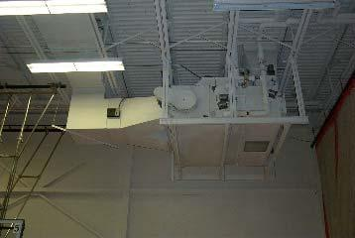

|  |  |  |
| --- | --- | --- |
| HV UnitsLocation: Bld. 600 Christie Room, sheet metal, gym, gym storage, custodial closet, 112, 111, 110, 203, learning center, nursing lab, Martin 3rd floorVoltages: 208v | | |
| *Step #* | *Energy Type* | **Shutdown Procedure** |
| 1 | any/all | Notify all affected employees of planned shutdown |
| 2 | electrical | Move disconnect to “off” position |
| 3 | electrical | Move circuit breaker to “off” position |
| 4 | hot water | Apply NMCC approved LOTO to breaker |
| 5 | hot water | Close valves to isolate hot water from system |
| 6 | hot water | Apply NMCC approved LOTO to valves |
| 7 | both | Let cool and drain unit |
| 8 | any/all |  |

|  |  |  |
| --- | --- | --- |
| HV UnitsLocation: Bld. 600 Christie Room, sheet metal, gym, gym storage, custodial closet, 112, 111, 110, 203, learning center, nursing lab, Martin 3rd floorVoltages: 208v | | |
| *Step #* | *Energy Type* | **Startup Procedure** |
| 1 | any/all | Check for complete reassembly |
| 2 | any/all | Check equipment to insure complete removal of tools, repair materials, etc. |
| 3 | any/all | Replace all covers/guards |
| 4 | hot water | Close drain valve |
| 5 | hot water | Refill unit with water. |
| 6 | hot water | Remove LOTO and device from isolating valve |
| 7 | electrical | Remove LOTO from breaker |
| 8 | electrical | Move breaker to “on” position |
| 9 | both | Activate start button to verify proper operation |
| 10 | any/all | Notify affected employees that the servicing or maintenance is complete  and the machine or equipment is ready for use |

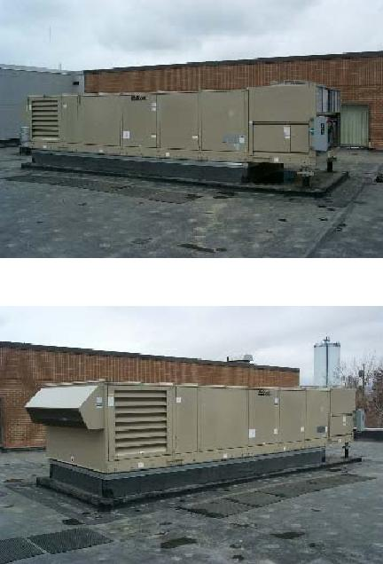

|  |  |  |
| --- | --- | --- |
| Roof Top HVAC UnitsLocation: Edmunds roof units 1,2 and 3Voltages: 208v | | |
| *Step #* | *Energy Type* | **Shutdown Procedure** |
| 1 | any/all | Notify all affected employees of planned shutdown |
| 2 | any/all | Shutdown equipment by turning the Pump Down switch to the manual  position and wait 5 minutes. |
| 3 | electrical | Move disconnect to “off” position |
| 4 | electrical | Apply NMCC approved LOTO to disconnect |
| 5 | hot water | Close valves to isolate hot water from system |
| 6 | hot water | Apply NMCC approved LOTO to valves |
| 7 | hot water | Let cool and drain unit |
| 8 | both | Measure voltages to verify all energy sources are removed |
| 9 | any/all | Perform required service according to manufacturer’s specs when  available |

|  |  |  |
| --- | --- | --- |
| Roof top HVAC UnitsLocation: Edmunds roof units 1,2 and 3Voltages: 208v | | |
| *Step #* | *Energy Type* | **Startup Procedure** |
| 1 | any/all | Check for complete reassembly |
| 2 | any/all | Check equipment to insure complete removal of tools, repair materials, etc. |
| 3 | any/all | Replace all covers/guards |
| 4 | hot water | Close drain valve |
| 5 | hot water | Refill unit with water. |
| 6 | hot water | Remove LOTO and device from isolating valve |
| 7 | electrical | Remove LOTO from disconnect |
| 8 | electrical | Move disconnect to “on” position |
| 9 | both | Activate start button to verify proper operation |
| 10 | any/all | Notify affected employees that the servicing or maintenance is complete  and the machine or equipment is ready for use |

***Service receptacle is powered from separate power source***

***Procedure does not include refrigerator system***

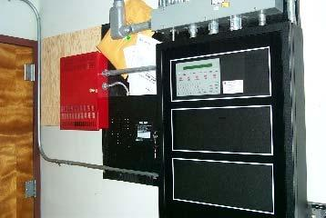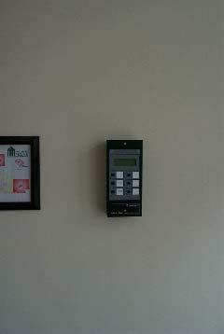

|  |  |  |
| --- | --- | --- |
| Fire AlarmLocation: CampusVoltages: 120v AC 24v DC | | |
| *Step #* | *Energy Type* | **Shutdown Procedure** |
| 1 | any/all | Notify all affected employees of planned shutdown |
| 2 | electrical | Move circuit breaker to “off” position |
| 3 | electrical | Apply NMCC approved LOTO to breaker |
| 4 | electrical | Disconnect batteries |
| 5 | electrical | Test and measure with a multi-meter that both AC and DC power have  been removed |
| 6 | any/all | Perform required service according to manufacturer’s specs when  available |

|  |  |  |
| --- | --- | --- |
| Fire AlarmLocation: CampusVoltages: 120v AC 24v DC | | |
| *Step #* | *Energy Type* | **Startup Procedure** |
| 1 | any/all | Check for complete reassembly |
| 2 | any/all | Check equipment to insure complete removal of tools, repair materials, etc. |
| 3 | any/all | Replace all covers/guards |
| 4 | electrical | Reconnect batteries |
| 5 | electrical | Remove NMCC approved LOTO from breaker |
| 6 | electrical | Move breaker to “on” position |
| 7 | any/all | Activate system to verify proper operation |
| 8 | any/all | Notify affected employees that the servicing or maintenance is complete  and the machine or equipment is ready for use |

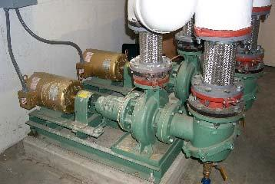

|  |  |  |
| --- | --- | --- |
| Circulation Pumps | | |
| *Step #* | *Energy Type* | **Shutdown Procedure** |
| 1 | any/all | Notify all affected employees of planned shutdown |
| 2 | electrical | Move circuit breaker to “off” position |
| 3 | electrical | Apply NMCC approved LOTO to disconnect |
| 4 | electrical | Verify that the power has been disconnect by measuring the voltage at the  motor |
| 5 | hot water | Shut off isolating valves |
| 6 | hot water | Apply NMCC approved LOTO to isolating valves |
| 7 | hot water | Let piping and equipment cool |
| 8 | hot water | Drain hot water from unit. |
| 9 | any/all | Perform required service according to manufacturer’s specs when  available |

|  |  |  |
| --- | --- | --- |
| Circulation Pumps | | |
| *Step #* | *Energy Type* | **Startup Procedure** |
| 1 | any/all | Check for complete reassembly |
| 2 | any/all | Check equipment to insure complete removal of tools, repair materials, etc. |
| 3 | any/all | Replace all covers/guards |
| 4 | hot water | Close drain |
| 5 | hot water | Refill unit with water |
| 6 | hot water | Remove NMCC approved LOTOs from isolating valves |
| 7 | hot water | Turn on isolating valves |
| 8 | electrical | Remove NMCC approved LOTO from disconnect |
| 9 | electrical | Turn on circulation pump disconnect |
| 10 | any/all | Activate system to verify proper operation |
| 11 | any/all | Notify affected employees that the servicing or maintenance is complete  and the machine or equipment is ready for use |

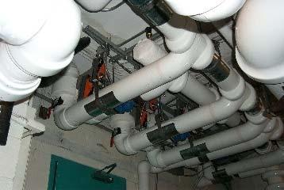

|  |  |  |
| --- | --- | --- |
| Zone ValvesLocation: CampusVoltages: 120vSingle breaker lockout | | |
| *Step #* | *Energy Type* | **Shutdown Procedure** |
| 1 | any/all | Notify all affected employees of planned shutdown |
| 2 | electrical | Move breaker to the “off” position on control circuit |
| 3 | electrical | Apply NMCC approved LOTO to breaker |
| 4 | electrical | Verify that the power has been disconnect by measuring the voltage at the  zone valve |
| 5 | hot water | Shut off isolating valves |
| 6 | hot water | Apply NMCC approved LOTO to isolating valves |
| 7 | hot water | Let piping and equipment cool |
| 8 | hot water | Drain hot water from unit. |
| 9 | any/all | Perform required service according to manufacturer’s specs when  available |

|  |  |  |
| --- | --- | --- |
| Zone ValvesLocation: CampusVoltages: 120vSingle breaker lockout | | |
| *Step #* | *Energy Type* | **Startup Procedure** |
| 1 | any/all | Check for complete reassembly |
| 2 | any/all | Check equipment to insure complete removal of tools, repair materials, etc. |
| 3 | any/all | Replace all covers/guards |
| 4 | hot water | Close drain |
| 5 | hot water | Refill unit with water |
| 6 | hot water | Remove NMCC approved LOTOs from isolating valves |
| 7 | hot water | Turn on isolating valves |
| 8 | electrical | Remove NMCC approved LOTO from disconnect or breaker |
| 9 | electrical | Turn on control circuit |
| 10 | any/all | Activate system to verify proper operation |
| 11 | any/all | Notify affected employees that the servicing or maintenance is complete  and the machine or equipment is ready for use |

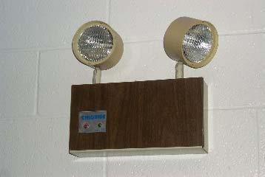

|  |  |  |
| --- | --- | --- |
| Emergency LightingLocation: CampusVoltages: 120v/277v AC 6v/12v DCDouble and single pole breaker lockout | | |
| *Step #* | *Energy Type* | **Shutdown Procedure** |
| 1 | any/all | Notify all affected employees of planned shutdown |
| 2 | electrical | Move breaker to the “off” position |
| 3 | electrical | Apply NMCC approved LOTO to breaker |
| 4 | electrical | Disconnect batteries |
| 5 | electrical | Verify that the power has been disconnected by measuring both AC and  DC power supplies |
| 6 | any/all | Perform required service according to manufacturer’s specs when  available |

|  |  |  |
| --- | --- | --- |
| Emergency LightingLocation: CampusVoltages: 120v/277v AC 6v/12v DCDouble and single pole breaker lockout | | |
| *Step #* | *Energy Type* | **Startup Procedure** |
| 1 | any/all | Check for complete reassembly |
| 2 | any/all | Check equipment to insure complete removal of tools, repair materials, etc. |
| 3 | any/all | Replace all covers/guards |
| 4 | electrical | Reconnect batteries |
| 5 | electrical | Remove NMCC approved LOTO from breaker |
| 6 | electrical | Turn on breaker |
| 7 | any/all | Activate system to verify proper operation |
| 8 | any/all | Notify affected employees that the servicing or maintenance is complete  and the machine or equipment is ready for use |

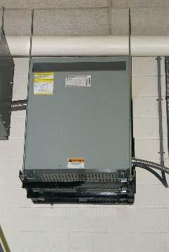

|  |  |  |
| --- | --- | --- |
| Transformer Step up/downLocation: CampusVoltages: 120v/208v/240v/277v/480vDouble and single and 3 pole breaker lockouts | | |
| *Step #* | *Energy Type* | **Shutdown Procedure** |
| 1 | any/all | Notify all affected employees of planned shutdown |
| 2 | electrical | Move breaker to the “off” position |
| 3 | electrical | Apply NMCC approved LOTO to breaker |
| 4 | electrical | Verify that the power has been disconnected by measuring the AC power  supply |
| 5 | any/all | Perform required service according to manufacturer’s specs when  available |

|  |  |  |
| --- | --- | --- |
| Transformer Step up/downLocation: CampusVoltages: 120v/208v/240v/277v/480vDouble and single and 3 pole breaker lockouts | | |
| *Step #* | *Energy Type* | **Startup Procedure** |
| 1 | any/all | Check for complete reassembly |
| 2 | any/all | Check equipment to insure complete removal of tools, repair materials, etc. |
| 3 | any/all | Replace all covers/guards |
| 4 | electrical | Remove NMCC approved LOTO from breaker |
| 5 | electrical | Turn on breaker |
| 6 | any/all | Activate system to verify proper operation |
| 7 | any/all | Notify affected employees that the servicing or maintenance is complete  and the machine or equipment is ready for use |

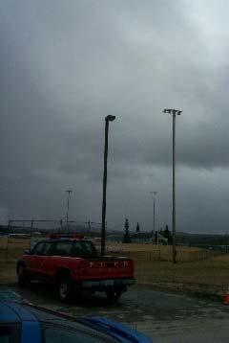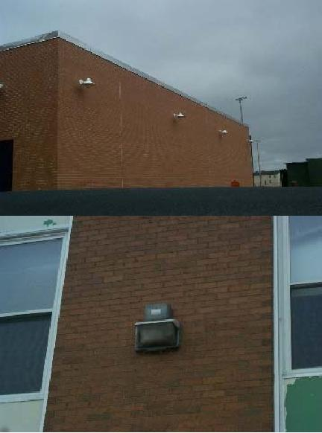

|  |  |  |
| --- | --- | --- |
| Outside LightingLocation: CampusVoltages: 120v/208v/277vDouble and single pole breaker lockouts | | |
| *Step #* | *Energy Type* | **Shutdown Procedure** |
| 1 | any/all | Notify all affected employees of planned shutdown |
| 2 | electrical | Move control and lighting breakers to the “off” position |
| 3 | electrical | Apply NMCC approved LOTO to breaker |
| 4 | electrical | Verify that the power has been disconnected by measuring the AC power  supply |
| 5 | any/all | Perform required service according to manufacturer’s specs when  available |

|  |  |  |
| --- | --- | --- |
| Outside LightingLocation: CampusVoltages: 120v/208v/277vDouble and single pole breaker lockouts | | |
| *Step #* | *Energy Type* | **Startup Procedure** |
| 1 | any/all | Check for complete reassembly |
| 2 | any/all | Check equipment to insure complete removal of tools, repair materials, etc. |
| 3 | any/all | Replace all covers/guards |
| 4 | electrical | Remove NMCC approved LOTO from breaker |
| 5 | electrical | Turn on breaker |
| 6 | any/all | Activate system to verify proper operation |
| 7 | any/all | Notify affected employees that the servicing or maintenance is complete  and the machine or equipment is ready for use |

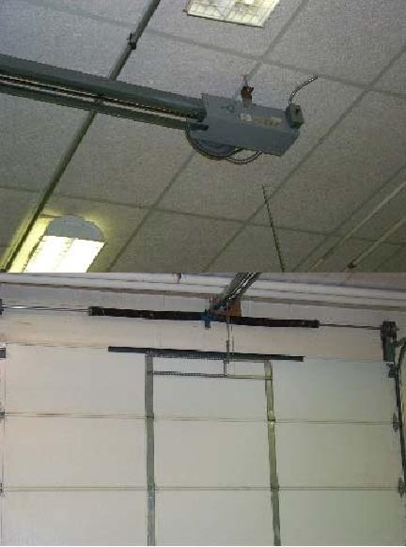

|  |  |  |
| --- | --- | --- |
| Overhead Door OpenerLocation: CampusVoltages: 120vSingle pole breaker lockout | | |
| *Step #* | *Energy Type* | **Shutdown Procedure** |
| 1 | any/all | Notify all affected employees of planned shutdown |
| 2 | electrical | Move breaker to “off” position |
| 3 | electrical | Apply NMCC approved LOTO to breaker |
| 4 | electrical | Verify that the power has been disconnected by activating door up and  down and by measuring the voltage at motor and controls |
| 5 | mechanical | Block to remove all gravity stored energy |
| 6 | mechanical | Release all spring stored energy |
| 7 | any/all | Perform required service according to manufacturer’s specs when  available |

|  |  |  |
| --- | --- | --- |
| Overhead Door OpenerLocation: CampusVoltages: 120vSingle pole breaker lockout | | |
| *Step #* | *Energy Type* | **Startup Procedure** |
| 1 | any/all | Check for complete reassembly |
| 2 | any/all | Check equipment to insure complete removal of tools, repair materials, etc. |
| 3 | any/all | Replace all covers/guards |
| 4 | mechanical | Remove blocking |
| 5 | mechanical | Reconnect springs |
| 6 | electrical | Reconnect batteries |
| 7 | electrical | Remove NMCC approved LOTO from breaker |
| 8 | electrical | Turn on breaker |
| 9 | any/all | Activate system to verify proper operation |
| 10 | any/all | Notify affected employees that the servicing or maintenance is complete  and the machine or equipment is ready for use |

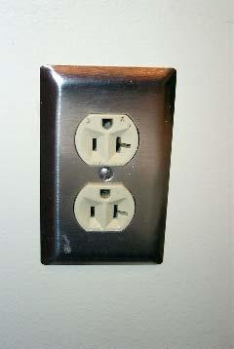

|  |  |  |
| --- | --- | --- |
| Electrical ReceptacleLocation: CampusVoltages: 120v/208v/240v/277v/480vDouble and single pole breaker lockout | | |
| *Step #* | *Energy Type* | **Shutdown Procedure** |
| 1 | any/all | Notify all affected employees of planned shutdown |
| 2 | electrical | Move breaker to “off” position |
| 3 | electrical | Apply NMCC approved LOTO to breaker |
| 4 | electrical | Verify that the power has been disconnected by measuring the voltage at  both receptacles |
| 5 | any/all | Perform required service according to manufacturer’s specs when  available |

|  |  |  |
| --- | --- | --- |
| Electrical ReceptacleLocation: CampusVoltages: 120v/208v/240v/277v/480vDouble and single pole breaker lockout | | |
| *Step #* | *Energy Type* | **Startup Procedure** |
| 1 | any/all | Check for complete reassembly |
| 2 | any/all | Check equipment to insure complete removal of tools, repair materials, etc. |
| 3 | any/all | Replace all covers/guards |
| 4 | electrical | Remove NMCC approved LOTO from breaker or disconnect |
| 5 | electrical | Turn on breaker or disconnect |
| 6 | any/all | Activate system to verify proper operation |
| 7 | any/all | Notify affected employees that the servicing or maintenance is complete  and the machine or equipment is ready for use |

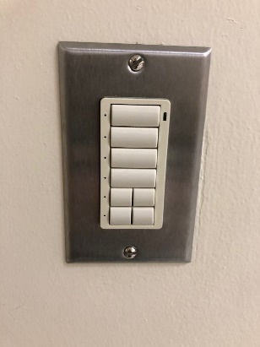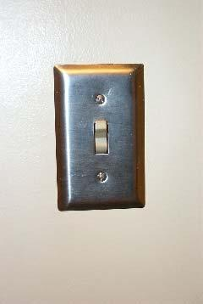

|  |  |  |
| --- | --- | --- |
| Electrical ReceptacleLocation: CampusVoltages: 120v/208v/240v/277vDouble and single pole breaker lockout | | |
| *Step #* | *Energy Type* | **Shutdown Procedure** |
| 1 | any/all | Notify all affected employees of planned shutdown |
| 2 | electrical | Move breaker to “off” position |
| 3 | electrical | Apply NMCC approved LOTO to breaker |
| 4 | electrical | Verify that the power has been disconnected by measuring the voltage at  the switch |
| 5 | any/all | Perform required service according to manufacturer’s specs when  available |

|  |  |  |
| --- | --- | --- |
| Electrical ReceptacleLocation: CampusVoltages: 120v/208v/240v/277vDouble and single pole breaker lockout | | |
| *Step #* | *Energy Type* | **Startup Procedure** |
| 1 | any/all | Check for complete reassembly |
| 2 | any/all | Check equipment to insure complete removal of tools, repair materials, etc. |
| 3 | any/all | Replace all covers/guards |
| 4 | electrical | Remove NMCC approved LOTO from breaker |
| 5 | electrical | Turn on breaker or disconnect |
| 6 | any/all | Activate system to verify proper operation |
| 7 | any/all | Notify affected employees that the servicing or maintenance is complete  and the machine or equipment is ready for use |

# REED DINING COMMONS

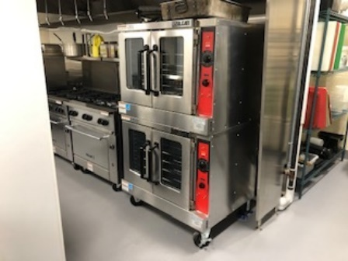

|  |  |  |
| --- | --- | --- |
| Convection OvensLocation: Reed CommonsVoltages: 208vDouble pole breaker lockout device | | |
| *Step #* | *Energy Type* | **Shutdown Procedure** |
| 1 | any/all | Notify all affected employees of planned shutdown |
| 2 | electrical | Move breaker to “off” position |
| 3 | electrical | Apply NMCC approved LOTO to breaker |
| 4 | electrical | Verify that the power has been disconnected by measuring the voltage at  the oven |
| 5 | thermal | Let equipment cool |
| 6 | any/all | Perform required service according to manufacturer’s specs when  available |

|  |  |  |
| --- | --- | --- |
| Convection OvensLocation: Reed CommonsVoltages: 208vDouble pole breaker lockout device | | |
| *Step #* | *Energy Type* | **Startup Procedure** |
| 1 | any/all | Check for complete reassembly |
| 2 | any/all | Check equipment to insure complete removal of tools, repair materials, etc. |
| 3 | any/all | Replace all covers/guards |
| 4 | electrical | Remove NMCC approved LOTO from breaker |
| 5 | electrical | Turn on breaker |
| 6 | any/all | Activate system to verify proper operation |
| 7 | any/all | Notify affected employees that the servicing or maintenance is complete  and the machine or equipment is ready for use |

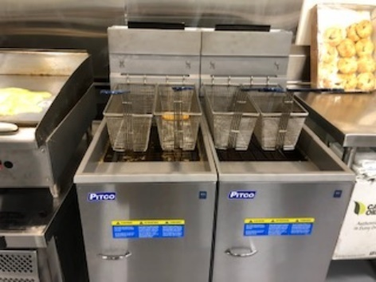

|  |  |  |
| --- | --- | --- |
| Deep FryersLocation: Reed CommonsVoltages: 208vSingle and Double pole breaker lockout device | | |
| *Step #* | *Energy Type* | **Shutdown Procedure** |
| 1 | any/all | Notify all affected employees of planned shutdown |
| 2 | electrical | Move breaker to “off” position |
| 3 | electrical | Apply NMCC approved LOTO to breaker |
| 4 | electrical | Verify that the power has been disconnected by measuring the voltage at  the fryer |
| 5 | thermal | Let equipment cool |
| 6 | any/all | Perform required service according to manufacturer’s specs when  available |

|  |  |  |
| --- | --- | --- |
| Deep FryersLocation: Reed CommonsVoltages: 208vSingle and Double pole breaker lockout device | | |
| *Step #* | *Energy Type* | **Startup Procedure** |
| 1 | any/all | Check for complete reassembly |
| 2 | any/all | Check equipment to insure complete removal of tools, repair materials, etc. |
| 3 | any/all | Replace all covers/guards |
| 4 | electrical | Remove NMCC approved LOTO from breaker |
| 5 | electrical | Turn on breaker |
| 6 | any/all | Activate system to verify proper operation |
| 7 | any/all | Notify affected employees that the servicing or maintenance is complete  and the machine or equipment is ready for use |

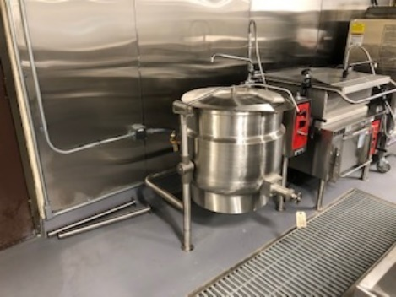

|  |  |  |
| --- | --- | --- |
| Steam KettleLocation: Reed CommonsVoltages: 120v/24 ACSingle pole breaker lockout | | |
| *Step #* | *Energy Type* | **Shutdown Procedure** |
| 1 | any/all | Notify all affected employees of planned shutdown |
| 2 | electrical | Move breaker to “off” position |
| 3 | electrical | Apply NMCC approved LOTO to breaker |
| 4 | electrical | Verify that the power has been disconnected by measuring the voltage at  the boiler |
| 5 | gas | Shut off gas valve |
| 6 | gas | Apply NMCC approved LOTO to gas valve |
| 7 | thermal | Let the equipment cool |

|  |  |  |
| --- | --- | --- |
| Steam KettleLocation: Reed CommonsVoltages: 120v/24 ACSingle pole breaker lockout | | |
| *Step #* | *Energy Type* | **Startup Procedure** |
| 1 | any/all | Check for complete reassembly |
| 2 | any/all | Check equipment to insure complete removal of tools, repair materials, etc. |
| 3 | any/all | Replace all covers/guards |
| 4 | electrical | Remove NMCC approved LOTO from breaker |
| 5 | electrical | Turn on breaker |
| 6 | any/all | Activate system to verify proper operation |
| 7 | any/all | Notify affected employees that the servicing or maintenance is complete  and the machine or equipment is ready for use |

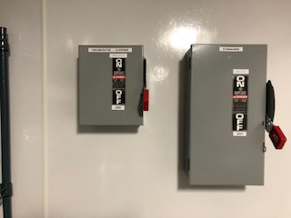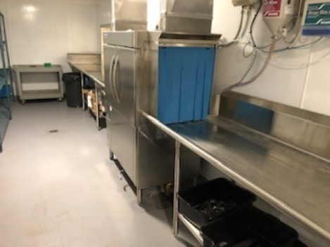

|  |  |  |
| --- | --- | --- |
| DishwasherLocation: Reed CommonsVoltages: 208v, 110 control3 phase breaker lockout | | |
| *Step #* | *Energy Type* | **Shutdown Procedure** |
| 1 | any/all | Notify all affected employees of planned shutdown |
| 2 | electrical | Move breaker to “off” position |
| 3 | electrical | Apply NMCC approved LOTO to local disconnect |
| 4 | hot water | Shut off hot water valve |
| 5 | hot water | Apply NMCC approved LOTO to hot water valve |
| 6 | electrical | Verify that the power has been disconnect by activating and by measuring  the AC supply |
| 7 | thermal | Let the equipment cool |
| 8 | any/all | Perform required service according to manufacturer’s specs when  available |

|  |  |  |
| --- | --- | --- |
| DishwasherLocation: Reed CommonsVoltages: 208v, 110 control3 phase breaker lockout | | |
| *Step #* | *Energy Type* | **Startup Procedure** |
| 1 | any/all | Check for complete reassembly |
| 2 | any/all | Check equipment to insure complete removal of tools, repair materials, etc. |
| 3 | any/all | Replace all covers/guards |
| 4 | electrical | Remove NMCC approved LOTO from local disconnect |
| 5 | hot water | Remove NMCC approved LOTO to hot water valve |
| 6 | hot water | Turn on hot water valve |
| 7 | electrical | Turn on disconnect |
| 8 | any/all | Activate system to verify proper operation |
| 9 | any/all | Notify affected employees that the servicing or maintenance is complete  and the machine or equipment is ready for use |



|  |  |  |
| --- | --- | --- |
| Propane Pizza OvenLocation: Reed CommonsVoltages: 120v / 20-amp ACSingle pole breaker lockout | | |
| *Step #* | *Energy Type* | **Shutdown Procedure** |
| 1 | any/all | Notify all affected employees of planned shutdown |
| 2 | electrical | Move breaker #30 in Panel KP2 to “off” position |
| 3 | electrical | Apply NMCC approved LOTO to breaker #30 in Panel KP2 |
| 4 | electrical | Verify that the power has been disconnected by measuring  the voltage at the boiler |
| 5 | gas | Shut off gas valve |
| 6 | gas | Apply NMCC approved LOTO to gas valve |
| 7 | thermal | Let the equipment cool |

|  |  |  |
| --- | --- | --- |
| Propane Pizza OvenLocation: Reed CommonsVoltages: 120v / 20-amp ACSingle pole breaker lockout | | |
| *Step #* | *Energy Type* | **Startup Procedure** |
| 1 | any/all | Check for complete reassembly |
| 2 | any/all | Check equipment to insure complete removal of tools, repair materials, etc. |
| 3 | any/all | Replace all covers/guards |
| 4 | electrical | Remove NMCC approved LOTO from breaker #30 in Panel KP2 |
| 5 | electrical | Turn on breaker #30 in Panel KP2 |
| 6 | any/all | Activate system to verify proper operation |
| 7 | any/all | Notify affected employees that the servicing or maintenance is complete  and the machine or equipment is ready for use |



|  |  |  |
| --- | --- | --- |
| Electronic Ballast Lighting Battery BackupLocation: CampusVoltages: 120v, 208v, 277vSingle and double pole lockout | | |
| *Step #* | *Energy Type* | **Shutdown Procedure** |
| 1 | any/all | Notify all affected employees of planned shutdown |
| 2 | electrical | Move lighting and ballast breaker to the “off” position |
| 3 | electrical | Apply NMCC approved LOTO to breakers |
| 4 | electrical | Disconnect battery backup at ballast |
| 5 | electrical | Verify that the power has been disconnected by activating light switch and  by measuring the voltage at the ballast |
| 6 | any/all | Perform required service according to manufacturer’s specs when  available |

|  |  |  |
| --- | --- | --- |
| Electronic Ballast Lighting Battery BackupLocation: CampusVoltages: 120v, 208v, 277vSingle and double pole lockout | | |
| *Step #* | *Energy Type* | **Startup Procedure** |
| 1 | any/all | Check for complete reassembly |
| 2 | any/all | Check equipment to insure complete removal of tools, repair materials, etc. |
| 3 | any/all | Replace all covers/guards |
| 4 | electrical | Reconnect batteries |
| 5 | electrical | Remove NMCC approved LOTO from breaker |
| 6 | electrical | Turn on breaker |
| 7 | any/all | Activate system to verify proper operation |
| 8 | any/all | Notify affected employees that the servicing or maintenance is complete  and the machine or equipment is ready for use |



|  |  |  |
| --- | --- | --- |
| Electronic Ballast LightingLocation: CampusVoltages: 120v, 208v, 277vSingle and double pole breaker lockout | | |
| *Step #* | *Energy Type* | **Shutdown Procedure** |
| 1 | any/all | Notify all affected employees of planned shutdown |
| 2 | electrical | Move breaker to “off” position |
| 3 | electrical | Apply NMCC approved LOTO to breakers |
| 4 | electrical | Verify that the power has been disconnected by activating light switch and  by measuring the voltage at the ballast |
| 5 | any/all | Perform required service according to manufacturer’s specs when  available |

|  |  |  |
| --- | --- | --- |
| Electronic Ballast LightingLocation: CampusVoltages: 120v, 208v, 277vSingle and double pole breaker lockout | | |
| *Step #* | *Energy Type* | **Startup Procedure** |
| 1 | any/all | Check for complete reassembly |
| 2 | any/all | Check equipment to insure complete removal of tools, repair materials, etc. |
| 3 | any/all | Replace all covers/guards |
| 4 | electrical | Remove NMCC approved LOTO from breaker |
| 5 | electrical | Turn on breaker |
| 6 | any/all | Activate system to verify proper operation |
| 7 | any/all | Notify affected employees that the servicing or maintenance is complete  and the machine or equipment is ready for use |

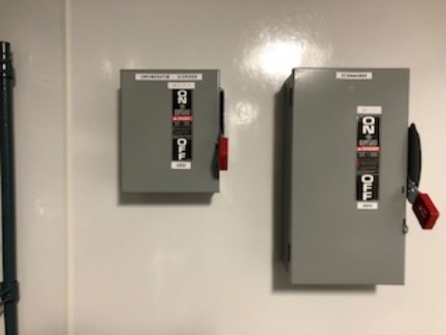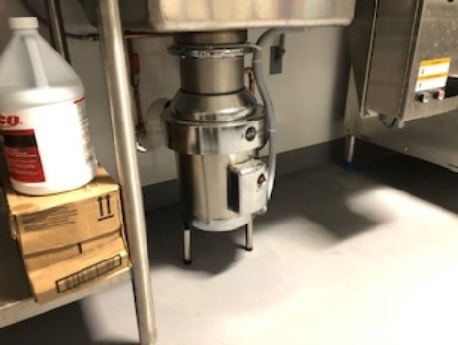

|  |  |  |
| --- | --- | --- |
| Disposer | | |
| *Step #* | *Energy Type* | **Shutdown Procedure** |
| 1 | any/all | Notify all affected employees of planned shutdown |
| 2 | any/all | Shutdown equipment operator controls |
| 3 | electrical | Move local disconnect to the “off” position |
| 4 | electrical | Apply NMCC approved LOTO local disconnect |
| 5 | electrical | Activate operator controls to verify all energy sources are removed |
| 6 | any/all | Perform required service according to manufacturer’s specs when  available |

|  |  |  |
| --- | --- | --- |
| Disposer | | |
| *Step #* | *Energy Type* | **Startup Procedure** |
| 1 | any/all | Check for complete reassembly |
| 2 | any/all | Check equipment to insure complete removal of tools, repair materials, etc. |
| 3 | any/all | Replace all covers/guards |
| 4 | electrical | Remove LOTO from local disconnect |
| 5 | electrical | Move local disconnect to “on” position |
| 6 | electrical | Activate system to verify proper operation |
| 7 | any/all | Notify affected employees that the servicing or maintenance is complete  and the machine or equipment is ready for use |

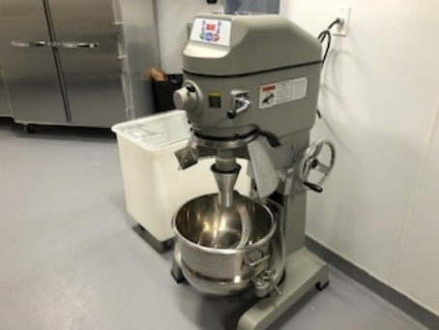

|  |  |  |
| --- | --- | --- |
| Mixer | | |
| *Step #* | *Energy Type* | **Shutdown Procedure** |
| 1 | any/all | Notify all affected employees of planned shutdown |
| 2 | any/all | Shutdown equipment operator controls |
| 3 | electrical | Move breaker #18,20,22 in panel HPK-1 to the “off” position |
| 4 | electrical | Apply NMCC approved LOTO to breaker #18,20,22 in panel HPK-1 |
| 5 | electrical | Activate operator controls to verify all energy sources are removed |
| 6 | any/all | Perform required service according to manufacturer’s specs when  available |

|  |  |  |
| --- | --- | --- |
| Mixer | | |
| *Step #* | *Energy Type* | **Startup Procedure** |
| 1 | any/all | Check for complete reassembly |
| 2 | any/all | Check equipment to insure complete removal of tools, repair materials, etc. |
| 3 | any/all | Replace all covers/guards |
| 4 | electrical | Remove LOTO from breaker #18,20,22 in panel HPK1 |
| 5 | electrical | Move breaker #18,20,22 in panel HPK1 to “on” position |
| 6 | electrical | Activate start button to verify proper operation |
| 7 | any/all | Notify affected employees that the servicing or maintenance is complete  and the machine or equipment is ready for use |

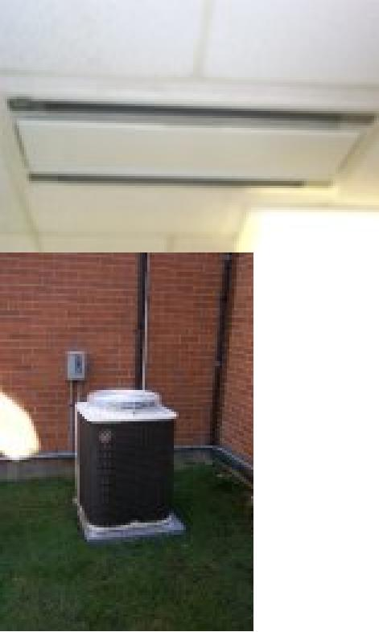

|  |  |  |
| --- | --- | --- |
| Air Conditioner | | |
| *Step #* | *Energy Type* | **Shutdown Procedure** |
| 1 | any/all | Notify all affected employees of planned shutdown |
| 2 | any/all | Shutdown equipment operator controls |
| 3 | electrical | Move breaker to the “off” position |
| 4 | electrical | Apply NMCC approved LOTO to breaker |
| 5 | electrical | Activate operator controls to verify all energy sources are removed |
| 6 | any/all | Perform required service according to manufacturer’s specs when  available |

|  |  |  |
| --- | --- | --- |
| Air Conditioner | | |
| *Step #* | *Energy Type* | **Startup Procedure** |
| 1 | any/all | Check for complete reassembly |
| 2 | any/all | Check equipment to insure complete removal of tools, repair materials, etc. |
| 3 | any/all | Replace all covers/guards |
| 4 | electrical | Remove LOTO from breaker |
| 5 | electrical | Move breaker to “on” position |
| 6 | electrical | Activate start button to verify proper operation |
| 7 | any/all | Notify affected employees that the servicing or maintenance is complete  and the machine or equipment is ready for use |

***Procedure does not include refrigerator system***

Reviewed and revised June 2014

Reviewed and revised June November 2020